Fuse5Scanner User Manual

- Login View: This view enables users to log into the fuse5 scanner app. The information you will need to log in is your Fuse5 Website Url, Fuse5 Username, and Fuse5 Password.

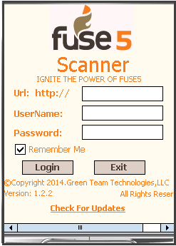
Here, user can check “Remember Me” check box for remember username and password for next time login.

- User Role View : Once logged in the User selects the function or User Type that they would like to perform from a list of roles as well as the location they would like to do work in. The User Type will default to what is set in the User default settings, but a user may select any other job in the drop down. This is also true for the location drop down.
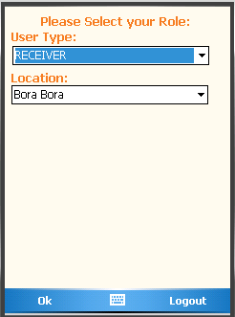

Depending on the role that is selected, the user will have an option to select the zone or zones they desire to work in. They will then be able to process all the picking options for the selected zone(s).

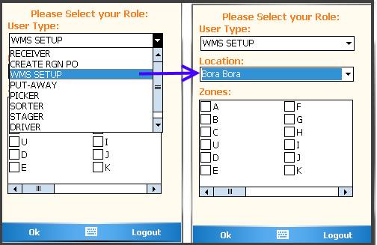
These are the common screens for all jobs, after the user logs in and selects the User Type, Location and possibly Zones the user can then go into specific job function screens as described below.

Custom Setting for login user for role based and location based privileges:

1. Restrict 'User Type' Privileges on Scanner: If Custom Setting 'Restrict 'User Type' Privileges on Scanner' is 'ON', Role options 'WMS Set up', and 'Physical Inventory' will not be a available for the Role's selected in Fuse5 at WMS and Scanner section.

2. Restrict User to Default Location on Scanner: Set 'Default Location' restriction on scanner based on User Preferences with this Custom Setting. When turned 'ON', only the 'Default Location' from 'User Preferences' will be available for those users roles selected.

- RECEIVER : This job function is to receive products into the warehouse from vendors. They can do that by Purchase Order Number, Receive By ASN# or if you have multiple locations Receive By Store Transfer number will also be available. The other option is to receive by both Store Transfer and Purchase Order number all at once with Receive By Product by simply scanning the products barcode numbers.

Receiver Dashboard:

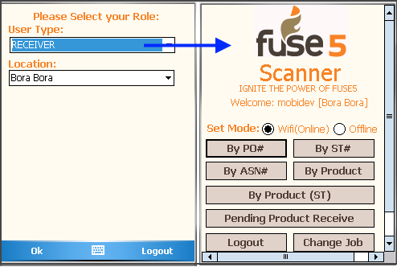
- Receive By PO#: This function allows the user to receive products by Purchase Order number.

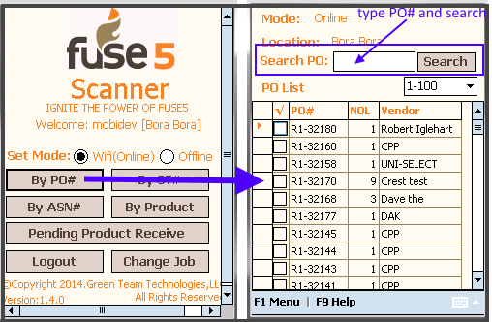
User can search specific PO by type PO# into search PO textbox and Hit Enter key of Device or tap search button.
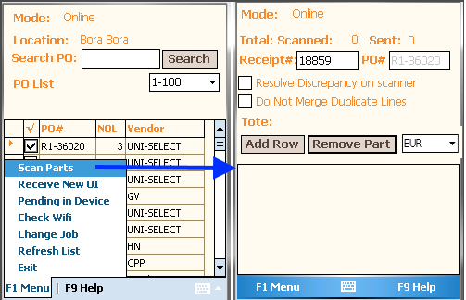
In the Receive by PO screen the select the PO# column by putting a check next to the purchase order and selecting 'Scan Parts' from the F1 Menu. Then in Scan page, start scanning products on the dock (associated with this PO).

Receiving Currency Dropdown: This option used to select receiving currency similarly in Fuse5 receive page currency selection.

Resolve Discrepancy on Scanner: This option enable user to view discrepancy popup after save received for backorder and cancel remaining parts.

Do Not Merge Duplicate Lines: This option enable user to scan and receive duplicate products with separate qty for each line rather than merge receive qty.

Receive To Tote (Dock): If user want to put away received products into tote, pallet or cardbox which created into Fuse5 – WMS >> Without PPL Physical Location, just go to the F1 menu >> Receive TO option and select tote/pallet/cardbox drop drop down list or scan barcode of tote/pallet/cardbox.
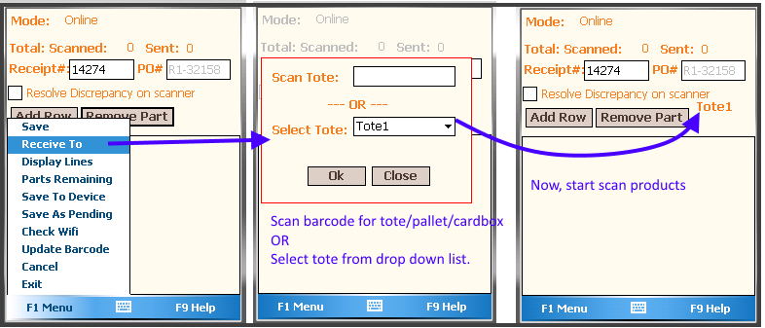
Here, Tote1 selected, it means user would put the parts into Tote1. If tote will be full by products and user want to another more tote or new tote, again go to F1 menu >> Receive To option and select or scan again.

NOTE: If you want to put away receiving item into tote, must be select beginning of scan products.

These are all received to totes will be display into PIG Role >> By Tote# functions.
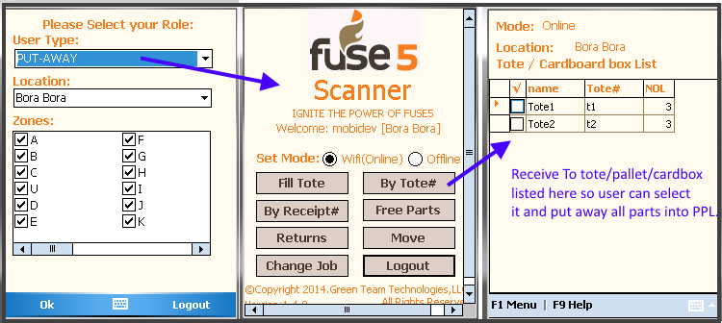
After Scanned, the screen will look like this:

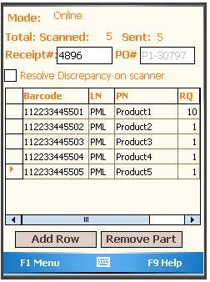

To look at the Menu Functions of this screen, Press F1 Menu . You will see many options in this screen and they are described below.

1.Save : This is used once a user is finished scanning. Selecting 'Save' will push the received inventory back to Fuse5. A status message will then appear on the scanner confirming the data has been synced.
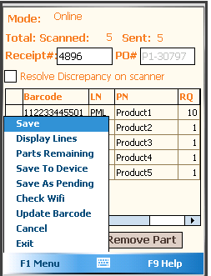

NOTE : IF you have WMS setup and would like to put away received products into its primary location, then just go to Fuse5 >> Custom Settings >> Receiving section >> Receive to Primary Location and make it ON. This feature automatically put away all received products from PO, ST and ASN put away into WMS.

2. Display Lines : This option displays the received report from Fuse5. Users can select the Purchase order number from purchase order number list page and view the receipt.

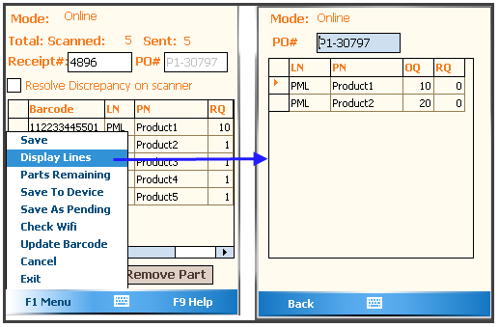

    - Part Remaining: This displays the Remaining parts that have not been received yet. This report can be viewed by entering the Purchase Order number from Fuse5.
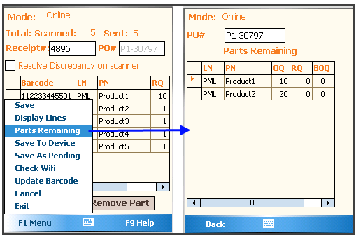

    - Save As Pending : This option allows user to save a receipt as pending into Fuse5. Pending Status allows the user to finish receiving the Purchase Order at a later date. This pending receipt can be opened from Receive Pending Products option on the Receiver Dashboard as well as in the Pending Product Received page from Fuse5 (Product Management >> Products Received >> Pending Product Received)

    - Save To Device: This option allow user to save data into device local database to later on save by restore this receipt.
    - Check Wifi : This option allow user to check that scanner is connected with wifi. Also it is check that if wifi is on and sacnner lost connection then make it to connection mode Online.
    - Update Barcode: This option allows users to update the barcode if the current barcode is incorrect or has changed.
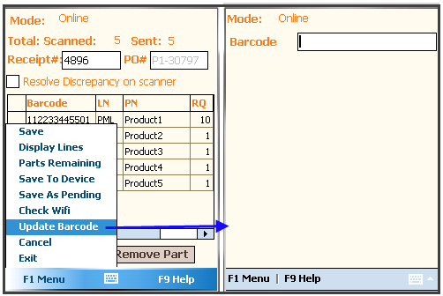
Scan barcode by Scanning them from a Scanner Gun or Type the barcode number into the Barcode textbox and click enter. The current product associated with the barcode entered will appear.

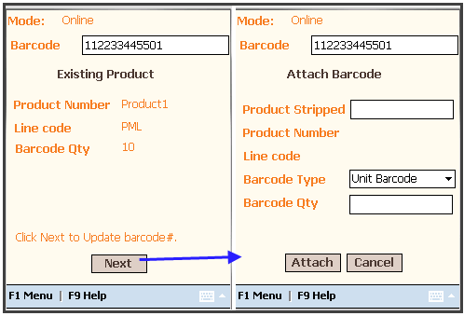
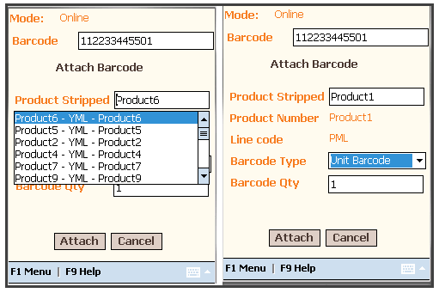

Step 3: Click Next to attach new product to this barcode.
Step 4: Type in the Product Stripped that you desire to update in the textbox. Hit enter to list the parts that include the typed, then select the product stripped that you would like to update. The user can also edit the Barcode Qty at this time.
Step 5: To Save (Attach) - Click Attach button to save into Fuse5.

    - Cancel: Using this functionality user can cancel the screen and go back to List page.
    - Exit : Using this function use can exit from this process but at this function user can save last scanned items as pending while exiting.

Pending In Device: This option allow user to restore pending receipt which have been saved into device by Exit or Save To Device option. To access this option, Go to Receive By PO >> PO List page >> F1 Menu >> Pending In device option.

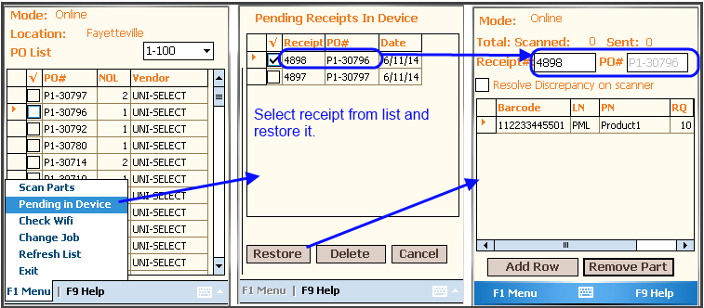
In this Pending Receipts in Device page, the select receipt by putting check on next column of receipt# and hit restore button to restore saved receipt into scan page for further process.

The next section we will talk about the Discrepancy Report. In order to Backorder or Cancel Items this option must be selected. Before Saving Select the box next to 'Resolve Discrepancy on Scanner'. After Saving, a discrepancy Parts listing will appear. From here you can select the box in the column BO to Backorder and CNL to Cancel the product.

Discrepancy Report : This function provides the option to decide which products will be backordered or canceled from the Purchase Order using the fuse5Scanner. You can also do this from Fuse5 as well.

Important : If you want to backorder / Cancel popup, you must check “Resolve Discrepancy on Scanner” checkbox before clicking 'Save'.
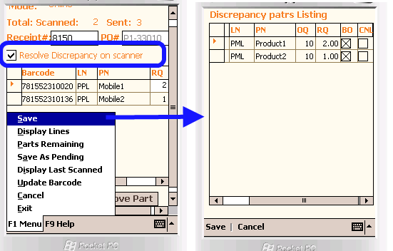
Append Product: This option allows users to add parts to the Purchase Order that were not originally on the order. Follow the Steps below to Append to a Purchase Order.
On Scan page of Receive By PO

=> Scan parts that you would like to append to the Purchase Order.
1) Append part in current PO#
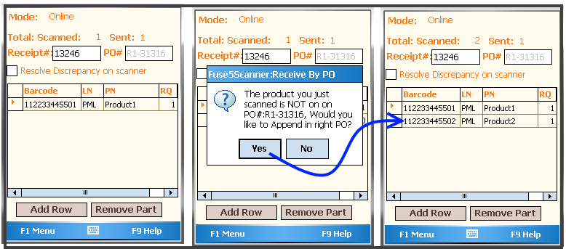

Here, once you scanned the part which was not in current PO#, then popup comes up which ask to user for Append. If YES then it would append in to current PO#. (Above attached screenshot).
If NO then further it ask for other PO#. as below:
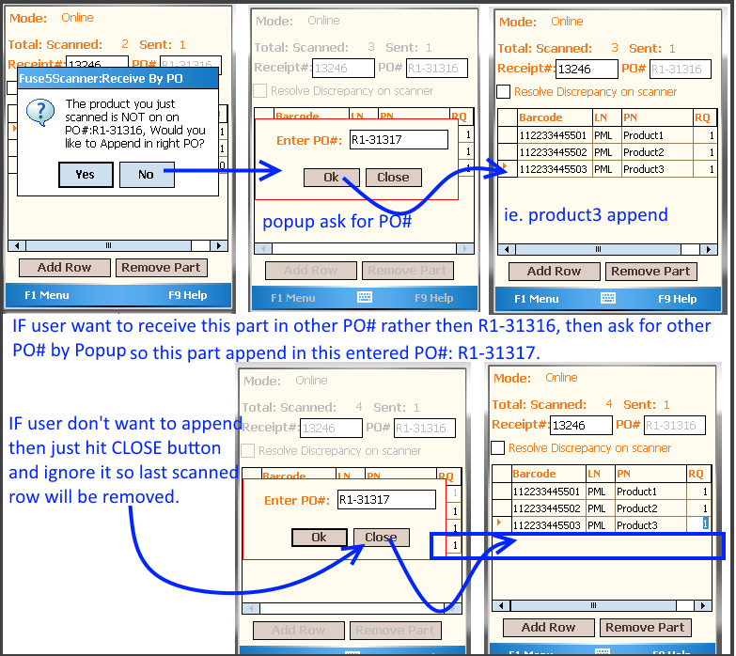

2 : IF NO then popup will appear that allows the user to enter which PO# or Purchase Order number they would like to Append the Parts to. Lastly select 'Save' from the F1 Menu to save to Fuse5.

Add Row manually (Add Row Button): This option allows users to manually type product numbers in row when scanner fails to scan or cannot recognize the barcode. Click the 'Add Row' button to insert a row to manually type in the barcode. Type in the Linecode, Product number and RQ. The user will now see that product was received. You can add more rows manually by repeating the same steps.
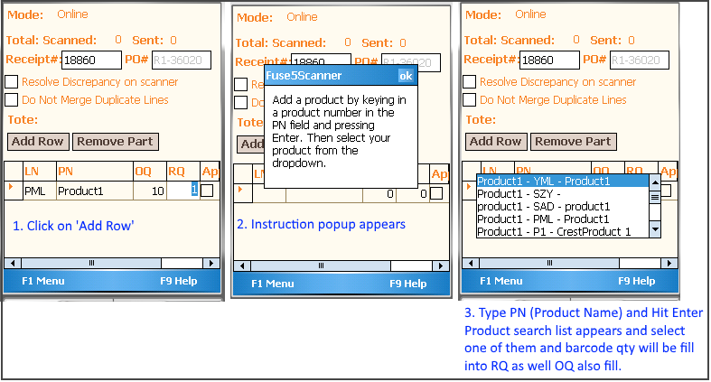
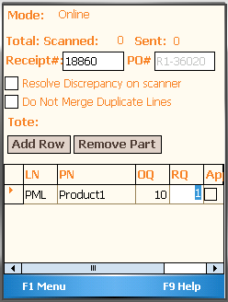

Cancel Purchase Order from Scanner: A purchase order can be completely canceled from the scanner by canceling all the parts off an order. A user can receive zero quantity of an item and cancel it using the backorder / cancel popup in the discrepancy report.

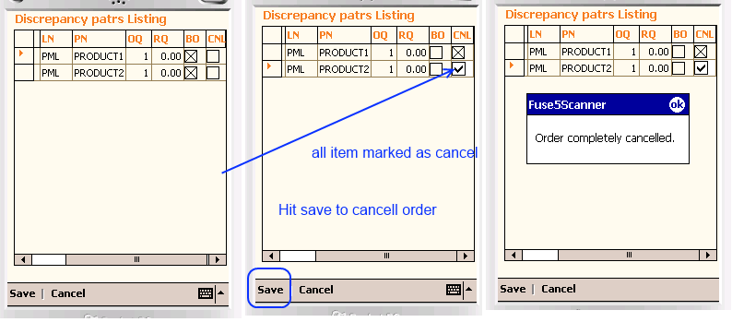
Validate PO overage receive: This option allow user to verify that more qty received then original ordered while save into Fuse5.
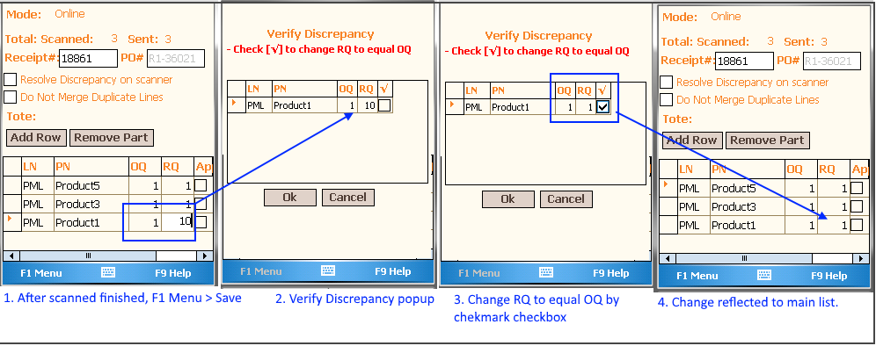

Here, scanner found that scanned qty 20 of product1 and its order qty was 10 so it showing popup for validate.
Now user can make it equal by copy order qty (OQ) to Received Qty (RQ) by check column OQ->RQ, OR user can edit OQ equal to RQ and edit RQ equal to OQ.

Receive By PO New UI: This option gives user to new UI flow with full screen single product scan rathar then grid view.

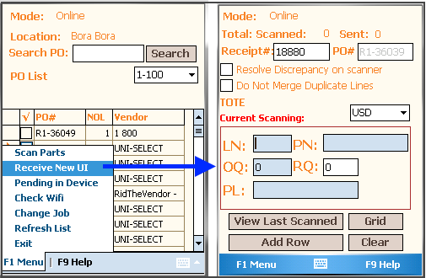
In this new user interface, user can scan product, view last scanned products, view all scanned products by Grid, Add New Row as similar to receive by product standard UI.

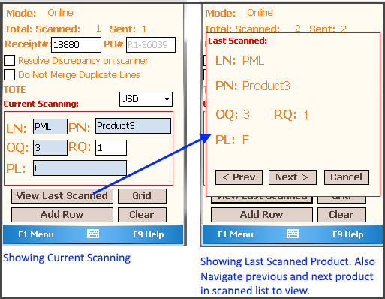
NOTE : All functions are same as receive by PO standard UI.

- Receive By ST# : This job allows the user to receive products by ST (Store Transfer) number. All the other receiving pages and process are the same as Receiving By Purchase Order number with the exception that a Store Transfer number is used rather then a Purchase Order number. A second key difference is that a store transfer is receiving products from another location instead of from a vendor as is the case with a purchase order. See below.

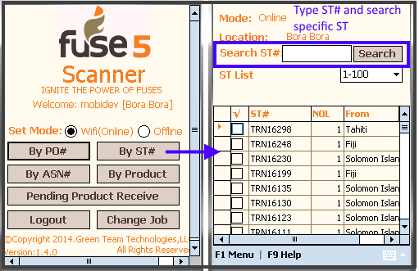
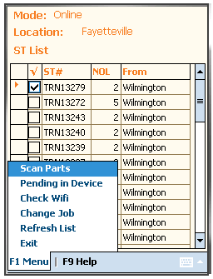
F1 Menu:

1 Scan Parts :

Select 'By ST #' from main screen. From the list of Store Transfer numbers select the one that you want to receive products off of and select 'Scan Parts.' Scan your parts in a similar way to when you are receiving by a Purchase Order number. After you are finished scanning, select Save from the F1 menu and the data will be synced into fuse5.

2 Pending in Device: This option allow user to restore back pending receipts which have been saved into device.
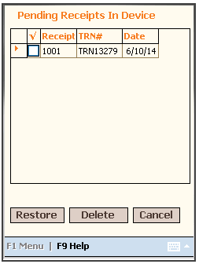
Select receipt# from this screen and hit 'Restore ' button to restore back device saved receipt into scan page for further process.
3 Check Wifi: This option enable user to check connection when connection lost.
4 Change Job: This option enable user to redirect current job role to another job role.
Refresh List: This option allow user to refresh the ST list to get fresh list from Fuse5.

=> Scan Page for Receive Products:
By ST# Menu Options
- Save : Sync to scan data to fuse5.
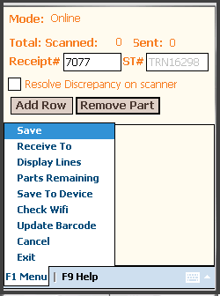
Validate ST overage receive: This option allow user to verify that more qty received then original ordered.

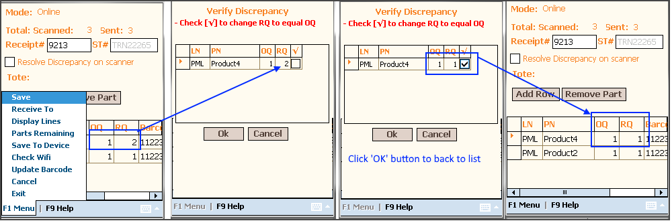
Here, scanner found that scanned qty 2 of product4 and its order qty was 1 so it showing popup for validate.
Now user can make it equal by checkmark the last column and change RQ to equal OQ and Hit OK to back to main list and then save it.

- Receive To : This option enable user to select/scan tote/pallet/cardbox for put away received items. Receive to tote, similar way in receive by purchase order.

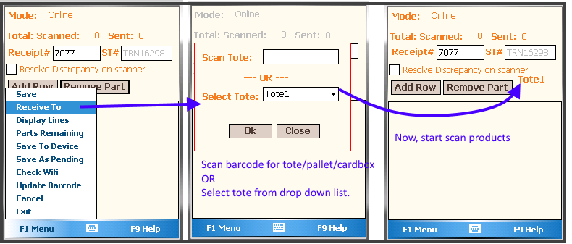

3 Display Line : Fuse5scanner will display the Barcode, Lincode, Product number and Received Quantity of all the items that have been scanned in off of a Store transfer number.
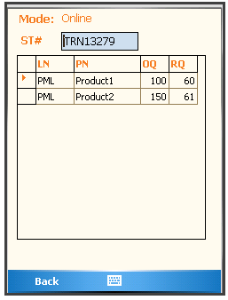
4. Parts Remaining : This report displays a list of the products that have not been received off of the Store Transfer yet. This information can be displayed by entering the Store Transfer number from Fuse5.
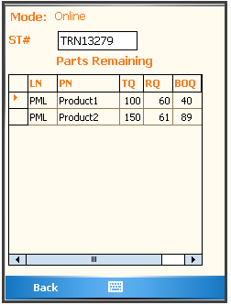
  - Save To Device: This option enable user to save into device as pending.
  - Check Wifi: This option enable user to check scanner connected with wifi or not.
  - Update Barcode: This option allows users to update the barcode if it's attached to the wrong product. (Same as Update barcode in Receive By PO).
  - Cancel: Using this functionality users can cancel the screen and go back to list page.
  - Exit : Using this function users can exit from this process. Before they completely exit the user is prompted to save last scanned items as pending while exiting.

Add Row manually (Add Row Button): This option allows users to manually type product numbers in row when scanner fails to scan or can not recognize the barcode. Click the 'Add Row' button to insert a row to manually type in the barcode. Type in the Linecode, Product number and RQ. The user will now see that product was received. You can add more rows manually by repeating the same steps. ( Same as Add Row in Receive by PO).

- Receive By ASN#: Thi function allow user to receive products by asn (Advance Shipping Notice) numbers. An ASN comes from the Vendor and telling you what to ship in reference PO#.

In the Receive by ASN# screen the select the ASN# column by putting a check next to the ASN# column and selecting 'Scan Parts' from the F1 Menu. Then in Scan page, start scanning products on the dock (associated with this ASN#). After Scanned, the screen will look like this:
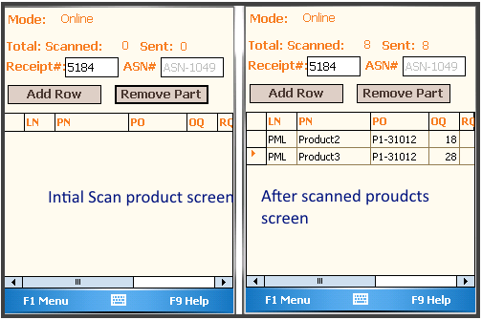
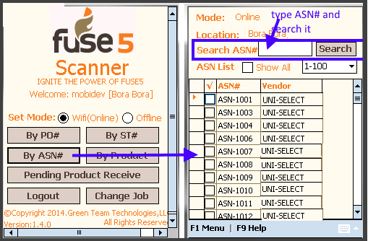
To look at the Menu Functions of this screen, Press F1 Menu . You will see many options in this screen and they are described below.
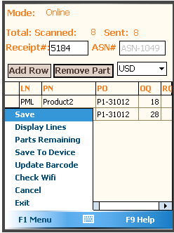

1.Save : This is used once a user is finished scanning. Selecting 'Save' will push the received inventory back to Fuse5. A status message will then appear on the scanner confirming the data has been synced
    - Receive To : This option allow user to select tote or scan tote to put away received items. Similar way that in receive by PO#.
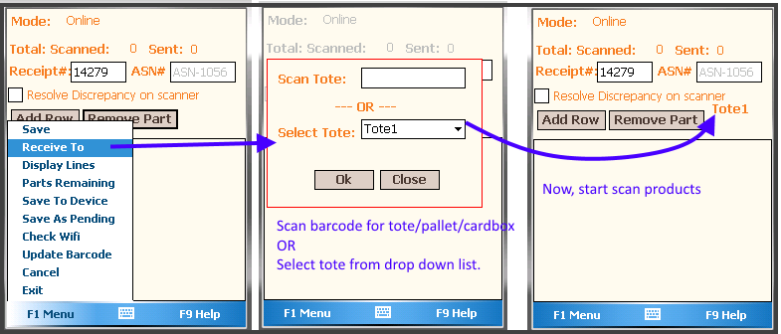
    - Display Lines : This option displays the received report from Fuse5. Users can select the ASN# from ASN# list page and view the receipt.

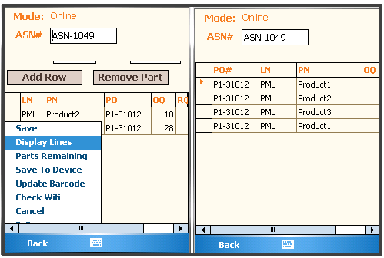
In this Display Lines screen, user can type ASN# and hit Enter key of scanner device to see another ASN# display lines report.
4. Part Remaining: This displays the Remaining parts that have not been received yet. This report can be viewed by entering the ASN# from Fuse5 or selecting ASN# from ASN# List page.
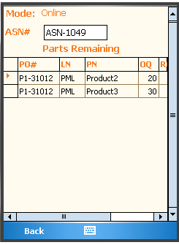
    - Save To Device: This option allow user to save data into device local database to later on save by restore this receipt.
    - Check Wifi : This option allow user to check that scanner is connected with wifi. Also it is check that if wifi is on and sacnner lost connection then make it to connection mode Online.
    - Update Barcode: This option allows users to update the barcode if the current barcode is incorrect or has changed. ( Same As Receive By PO. See screen shot help).
    - Cancel: Using this functionality user can cancel the screen and go back to List page.
    - Exit : Using this function use can exit from this process but at this function user can save last scanned items as pending while exiting.

Append Product: This option allows users to add parts to the ASN# with reference Purchase Order that were not originally on the order. Follow the Steps below to Append to a Purchase Order. On Scan page of Receive By ASN#.
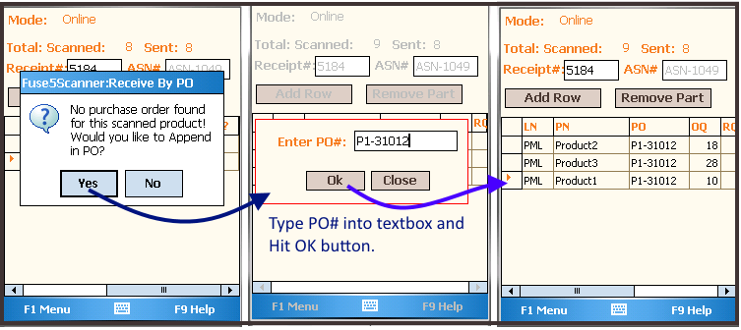
Step1 : Scan parts that you would like to append
Step2 : Hit Yes button in warning popup and then Enter PO# popup will be open.
Step3 : Type reference PO# and Hit OK button.
Add Row manually (Add Row Button): This option allows users to manually type product numbers in row when scanner fails to scan or cannot recognize the barcode. Click the 'Add Row' button to insert a row to manually type in the barcode. Type in the Linecode, Product number and RQ, barcode. The user will now see that product was received. You can add more rows manually by repeating the same steps. (As same as receive by PO#).

- Receive By Product : This function allows the user to scan products and receive multiple Purchase Orders by multiple vendors all at once. This is a really convenient and time saving option but doesn't work if you are receiving the same products from multiple vendors or multiple Purchase Orders at the same time (it does work for that, but you have to stop and select which PO# you're receiving.)

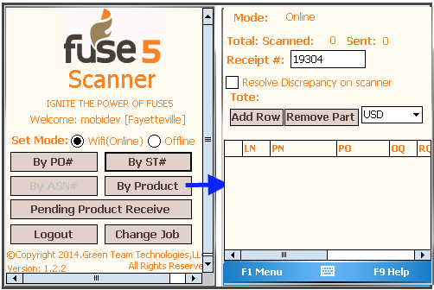
To use the 'Receive by Product' module scan the product barcodes. Once you scan the product barcode the scanner will list the Purchase Order numbers that are associated with that product in the PO column, as well as the order qty in the OQ or Order Quantity column.
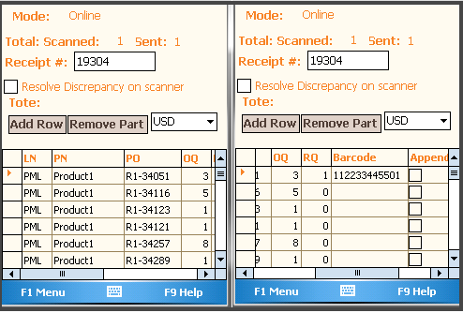
Here, users can enter/type manually in RQ ( Received Quantity) column cell for particular Purchase Orders or scan the products.
Append Product : This option allows users to add parts to be received on the purchase order that were not originally on the purchase order.
Step 1: Scan the product that you would like to append to the purchase order.
Step 2: On the line of the product that was just scanned check the box in the “Append?” column.
Step 3: In Popup, enter the PO# and Hit OK.

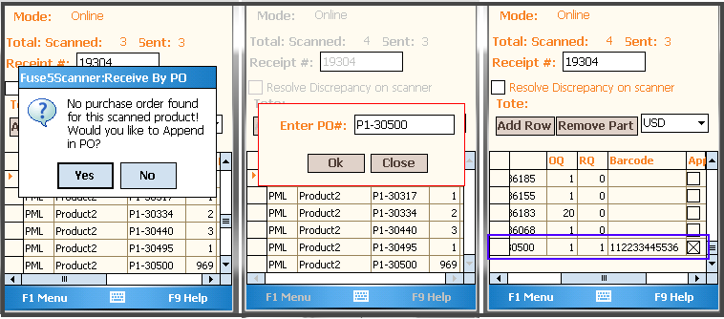

If scanned product have no purchase order and user want to append, then below steps will help you:
Step 1: Scan product
Step 2: Alert message popup if scanned product have no PO.
Step 3: If you want to append then Tap on Yes and Go ahead. (like below image)

If you don't want to append, then Tap Close and ignore it.

After finish receiving, hit F1 Menu >> Click Save to sync the scanned data into Fuse5.

- Save As Pending : This option allows user to save a receipt as pending into Fuse5 so that they may finish it later or they can Exit to switch jobs. This pending receipt is available to open from the Receive Pending Products Listings page as well as from Fuse5 as well. (Product Management >> Products Received >> Pending Product Received)
- Save To Device : This option allows users to save a receipt as pending into Device so that they may finish it later or they can Exit to switch jobs. This pending receipt is available to open from Device to do further process.
- Pending In Device: This option enable user to restore back from Device.
- Update Barcode : Allows users to update the barcode when wrong barcodes are attached to product or when the barcode has changed.
- Cancel: Using this functionality user can cancel the screen and go back to List page.

- Exit : Using this function use can exit from the receiving process. Prior to completely leaving this screen the user can save last scanned items as pending while exiting.
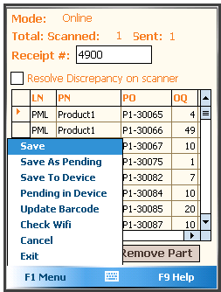
Manually Enter product :
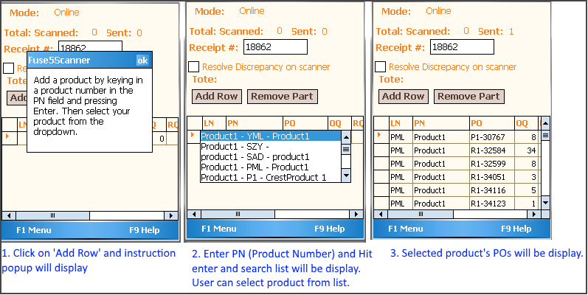
NOTE : To get the list of Purchase Orders, type in Linecode and Product Number and hit enter key. This will display a list of Purchase Orders that the selected product is on. On the row of the purchase order that you would like to receive change the RQ or Received Quantity and hit enter. To add another row click the 'Add Row' button and repeat.

Backorder / Cancel in Receive By Product:
- Receive by product by checking "Resolve Discrepancy's in Scanner".
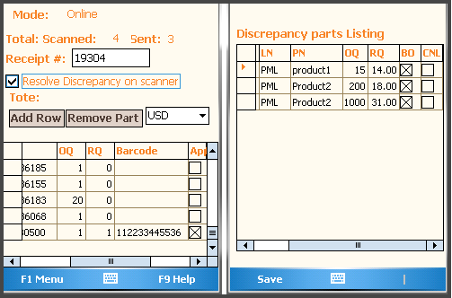

NOTE: Here, users can scan one part (ie. Product1) which is on multiple open Purchase Orders waiting to be received (ie. P1-30169, P1-30258, P1- 30286 etc ). The Fuse5scanner shows the barcode qty in first column of this product (ie. row: P1-30169 - set RQ is 50) and the next rows will show all alternative Purchase Orders awaiting this product. (ie. P1- 30258 has default 0) so users can manually edit the Received Quantity column because the scanner doesn't know which Purchase Order you're receiving.

- Receive by product with the 'Resolve Discrepancy's in Scanner' checked allows the user to view the back order / cancel pop up and select whether the remaining quantity of the part should be backordered or canceled.

Pending Product Receive: This option allows users to open pending product receipt and update or receive into Fuse5.
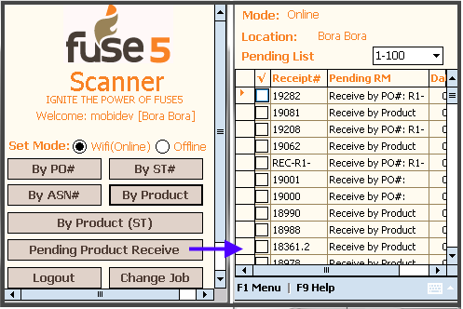
Step 1 : Restore pending product receipt : To restore the receipt click the 'Pending Product Receive' button and select one of pending list and hit F1 menu > Click Restore.
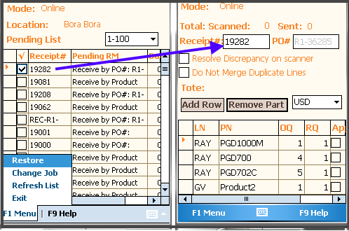
Here, user can update quantity by scanning more products and receive this receipt by hitting “Save” or pending by selecting“Save as pending”.
    - Receive By Product (ST): This function allows the user to scan products and receive multiple store transfers from multiple from location all at once. This is a really convenient and time saving option but doesn't work if you are receiving the same products from multiple Store Transfers at the same time (it does work for that, but you have to stop and select which TRN# you're receiving.)
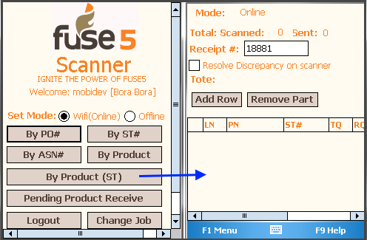
To use the 'Receive by Product (ST)' module scan the product barcodes. Once you scan the product barcode the scanner will list the Store Transfer numbers that are associated with that product in the ST# column, as well as the order qty in the TQ or Transfer Quantity column.
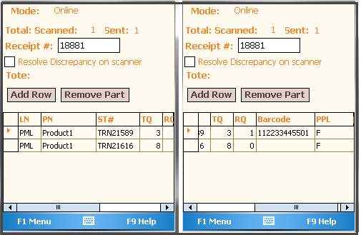
Here, users can enter/type manually in RQ ( Received Quantity) column cell for particular Store Transfer or scan the products.

After finish receiving, hit F1 Menu >> Click Save to sync the scanned data into Fuse5.

- Save : This option allows user to save a receipt into Fuse5.
- Receive To: This option allow user to put away received products into tote. This tote is create from Product >> WMS >> Without PPL Physical Location
- Save To Device : This option allows users to save a receipt as pending into Device so that they may finish it later or they can Exit to switch jobs. This pending receipt is available to open from Device to do further process.
- Pending In Device: This option enable user to restore back from Device.
- Update Barcode : Allows users to update the barcode when wrong barcodes are attached to product or when the barcode has changed.
- Cancel: Using this functionality user can cancel the screen and go back to List page.

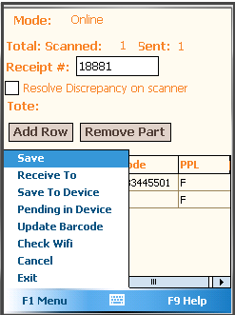
7. Exit : Using this function use can exit from the receiving process. Prior to completely leaving this screen the user can save last scanned items as pending while exiting.

Custom Settings for Receive Module at WMS & Scanner Section at Fuse5:

1. Receive to Primary Location: Fuse5 will automatically increase PPL Qty when Products with 'Default Locations' are received. This functionality works in conjunction with the Custom Setting 'Product Default Location'. 'Receive to default location' will only increase PPL Qty for products with set a 'Default Location'.

2. Product Default Location: Set a default location for WMS Products under the tab Product Management=>Products=>WMS=>Physical Location. Products may only have one default location.

3. Update PPL Qty as Product Qoh Automated Every Day: This CS enable user to update PPL Qty as Product Qoh Automated Every Day. Option 'Yes': PPLQty will set as product QOH every day by cron. Option 'No': PPL Qty will not as product QOH

4. Force 'Receive To' in 'Receiver': This setting enable user to set that user has to Receive scanned products into receiving tote and scanner validate it while F1 Menu >> Save. If “Yes” - Then must select receiving tote and “NO” - optional to receive into tote.

2. Create RGN PO: This job function allow user to add and update the parts into pending Return Goods Note Purchase order or RGNPO in Fuse5 by scanning all parts for the RGN PO the user would like to process. This will reduce your inventory similar to an RGN PO in Fuse5.
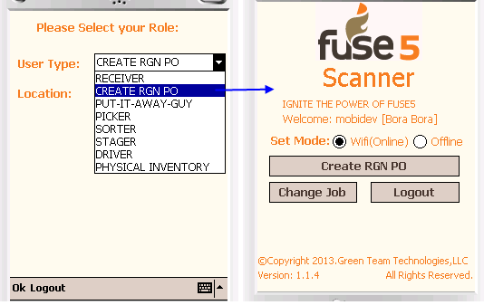
Step 1: From your role select 'Create RGN PO'. This will direct the user to a list of Pending RGN's.
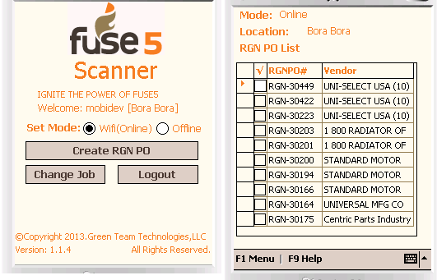

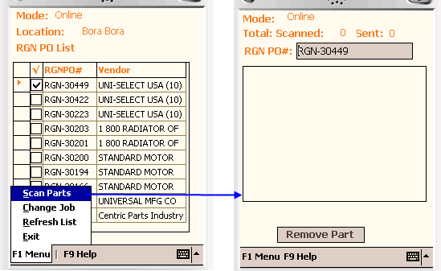
At the RGN PO listings page a user can select one of RGN Pos from the list by clicking the box next to the RGNPO# column. These are list of Pending RGN Pos that the user is able to add products to when the user desires to return products to the vendor.

Step 2: Once the desired PO is selected at the listings page, a user will add parts by selecting 'Scan Parts' from the F1 Menu and scanning each part individually. When the user is finished scanning parts to the RGN PO they can save their work by hitting the “Save As Is” from the F1 Menu to sync data into Fuse5.

Change Job: Redirects the user back to the main screen where the job and location can be changed.
Display Last Scanned: By clicking this option from the 'F1 Menu' the Fuse5scanner will recall the last items scanned that are stored on the devices memory.
Cancel: Using this functionality, a user can cancel the screen and go back to List page.
Exit : Using this function use can exit from the receiving process. Prior to completely leaving this screen the user can save last scanned items as pending while exiting.

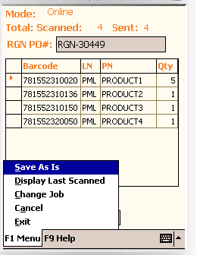

Pending in Device: This menu option allow user to restore data from device which was saved previously by Exit on Scan Parts page into Device.
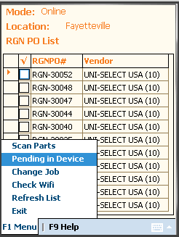
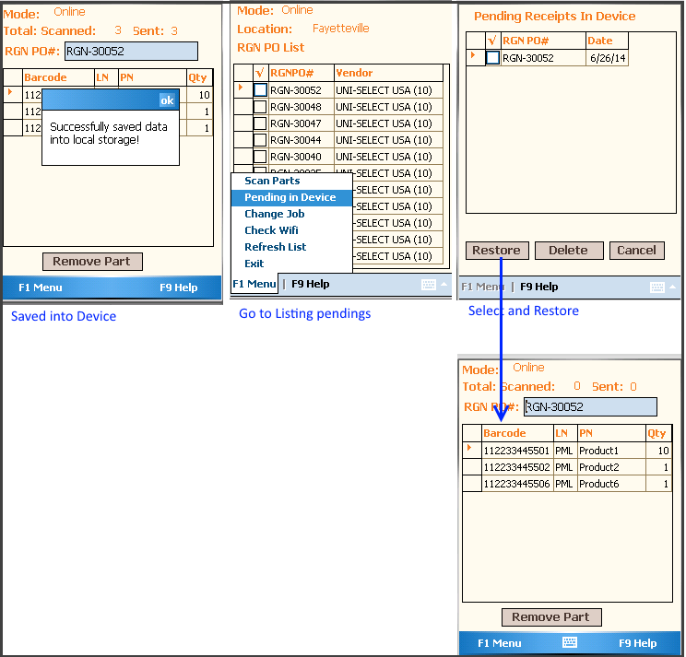
3. WMS SETUP: This job function allow users to assign barcode to product physical location as well load products into physical location(Zone/aisle/shelf/bin etc).when users first are setting up WMS, they will have to do physical inventory of their whole warehouse to tell fuse5 where everything is.

Select “WMS setup” at Role selection screen and go to WMS Setup dashboard screen.
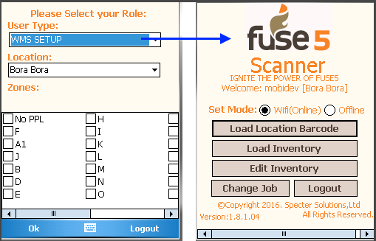
- Load Location Barcode: This function enable user to assign barcode to product physical location.

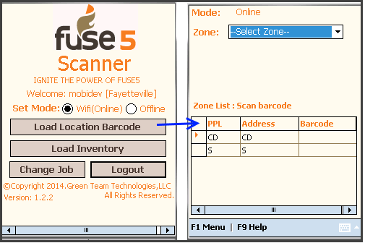
Here user can get the initial screen of load location barcode by hit the Load Location Barcode button at Dashboard screen. Now you can see zone drill down for zone selection and zone list in gird where user can scan barcode and assign to location.

If user want to assign barcode to shelves, aisles, bins then user select drill down of parent location like if Aisle then select zone from zone drill down then aisle listed into grid so user can scan barcode for that.

Here, use selected “CD” zone so under this zone, aisle list 12, 34, 56 listed into grid and then user can scan barcode and assign them.
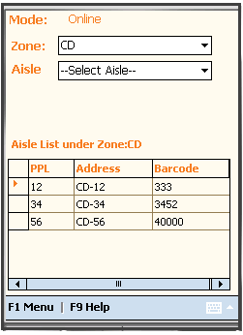
Also user can see Ailse drip down using that user can assign barcode to these location which are under selected Aisle.
i.e. if Aisle : 12
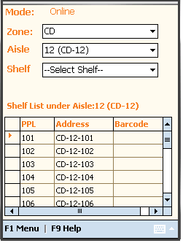

i.e. user want to assign barcode to bins then select Shelf from shelf drip down
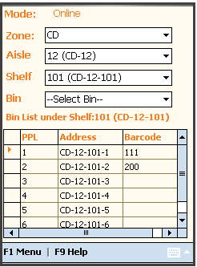

After finish scan, hit F1 menu to get several options for do several action.
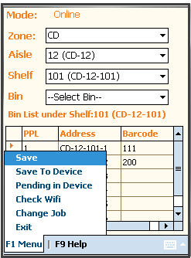
F1 menu options:

- Save : This option allow user to save scanned and assigned barcode to physical location back to Fuse5.
- Save To Storage: This option allow user to save data into device database as pending.
- Pending In Device: This option allow user to restore back from device pending into screen for save to fuse5.

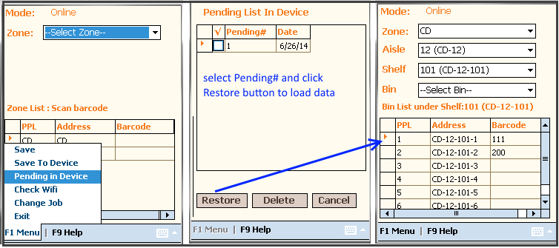
Select 'Pending#' and hit Restore button to load scanned history to screen for save into fuse5.

- Load Inventory: This function enable user to load products into product physical location when first time WMS setup. There are two way to select location: 1) select location from drill down OR 2) By Scan location

Here, user can load product at zone, shelf , bin, tote, pallet by select option in location drill down.

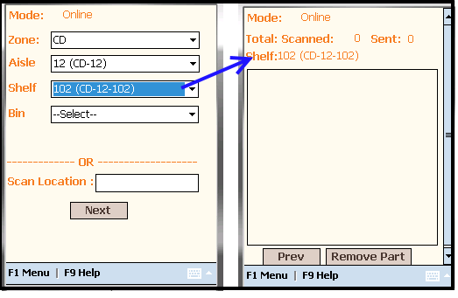
OR user can directly go to location and scan it to load product into.
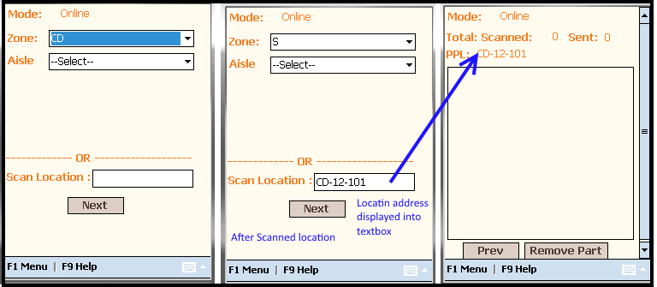
After that location selection, user move to scan products screen for load parts to this location.

Now scan products.

After finish scanned, user can do several functions using F1 Menu:
- Save : This option allow user to save scanned products into Fuse5 WMS inventory.
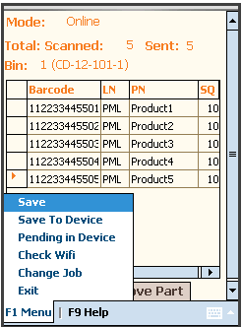
- Save To Device : This option allow user to save as pending into Device for later on use.
- Pending in Device: This option allow user to restore pending of Device into screen so user can save into Fuse5.
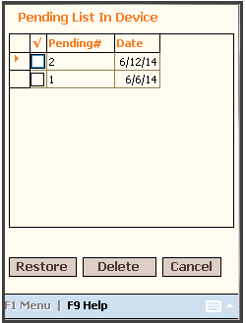
Select one of pending# from list and hit Restore button to load it's products into screen so use can save into Fuse5.

Edit Inventory: This job function provide the user with the ability to edit Products Physical Location (PPL) Quantity or location (Move or edit qty).

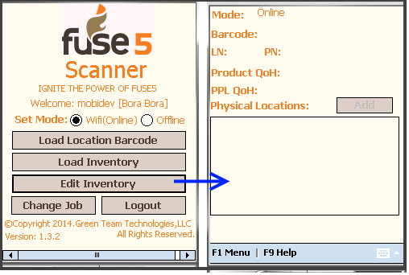
Here user can get the initial screen of Edit Location by hit the Edit Location button at Dashboard screen. Now you can see initial screen for edit inventory, where user can scan product to view its details with product QoH and its physical location qty.
Step 1 : Scan Product to display product details and user can edit PPL qty.

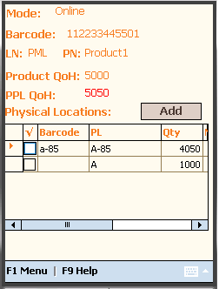
Here, we can see Product QoH and PPL QoH. PPL QoH is in Red color font, it indicated that it is not equal to product QoH. When user will adjust location qty in grid to make it equal, then PPL QoH color will be green.

Add Location : User can add location by Tapping on Add button on Top over the grid.
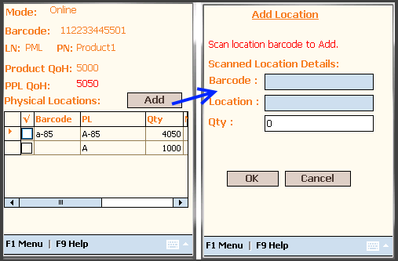
Now, we can see Add location screen, here user can scan the location which he want to add and enter Qty of parts they want to load on this new location. Then Hit OK to add into grid. It will committed into Fuse5 WMS after Save.
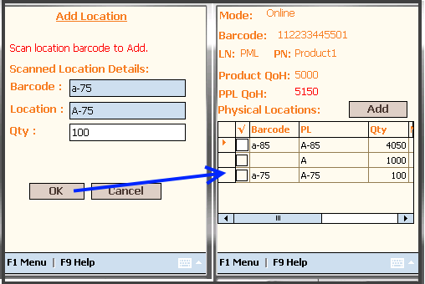
Edit Location (Move) : User can Edit location means move parts from one location to another with specific qty by Click on checkbox on first column of grid besides to Barcode column. Then Move location popup will open where user can scan move location and entered move qty and Hit OK to edit in grid and then Save into Fuse5 WMS.
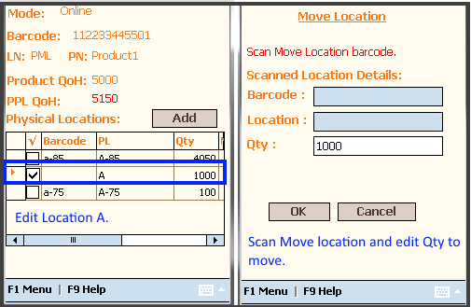

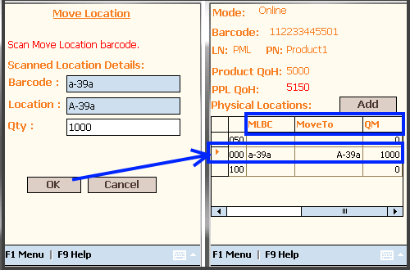
Here, we can see Move location details in grid in edit row.
*MLBC – Move Location Barcode
*QM – Qty Move

Edit Qty in Existing Location: User can edit qty to make it equal to product QoH.

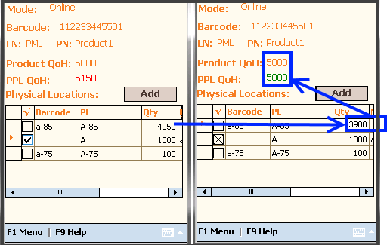
After all changes, user can save it Using F1 menu.
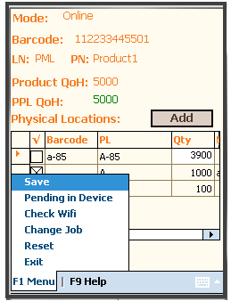
- Save : To save all changes into Fuse5.
- Pending in Device: To restore the pending from device database so user can save it into Fuse5.
- Check Wifi : To check that scanner will connected with wifi or not.
- Reset: To reset the screen, user can clear all screen data to again scan new data
- Exit: This function enable user to exist from current function and go to dashboard.

4. PUT AWAY :This job follows the “RECEIVING” job and will assist that user in knowing what needs to be put away and where to put it. In this process the fuse5scanner display is more concerned about where the parts should go, not necessarily which Purchase Order or Store Transfer the part came in on. This is the step that updates the PPL or Product Physical Location inventory in Fuse5 with the final location each product is placed in.

Select “Put It Away Guy” Role at Role selection Screen from the User Type drop down and the PUT IT AWAY GUY dashboard screen appears. Note that the Zones appear for this User Type so be sure to select the correct zone or zones that this user will be working in. You will notice that the Put It Away Guy has many options for stocking items, we will go over all of them below.
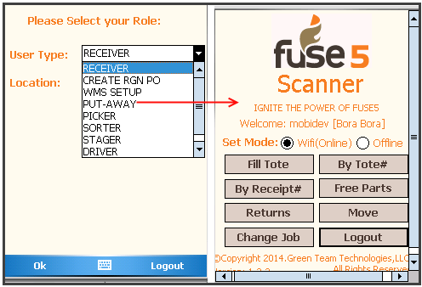

- By Receipt#: Users are able to put away one or more receipts at a time into a tote using this option.
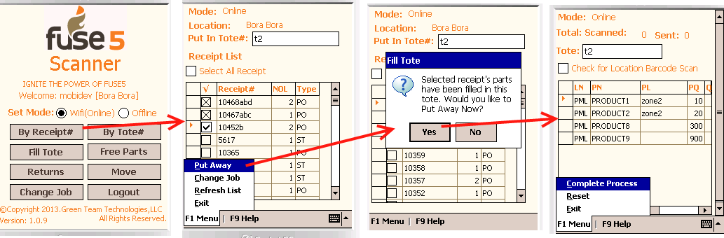
Step 1: Select one or more 'Receipt#' by selecting the box in the Check column on the far left of the screen.
Step 2: Scan or type the tote barcode into the 'Put it in Tote#' the user would like to identify as these parts being in and textbox at top of the screen
Step 3: Select 'Put Away' from F1 menu to save this tote. After the user is finished saving, a message box appears verifying the user “Would you like to Put Away Now?” - if YES then a scanning page will appear scan products to be put away.
Step 4: Select 'Complete Process' to update the Product Physical Location.

- By Tote# : Users will select one tote from tote# ( Saved by ByReceipt action) list and put away at the Product Physical location.

Step 1: Select 'By Tote number' from the main screen.
Step 2: From the list of Totes select the Tote # that you would like to Put Inventory away in. Select 'Put Away Now' .
Step 3: Scan the Products that you would like to Put Away in the selected tote.
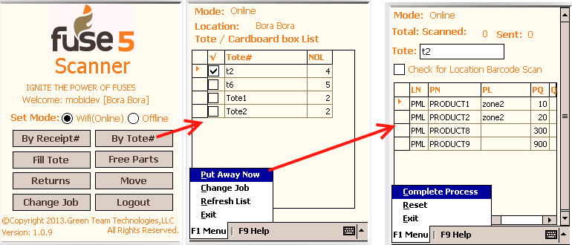
At Scan Page – How to Scan part?
There are two options:
        - Without Location barcode scan : If your warehouse does not have Physical Product location barcodes, then the default location is used to Put away location “PL”. In this option there is no need to scan a location barcode. Simply just select on location and Scan each product one by one.
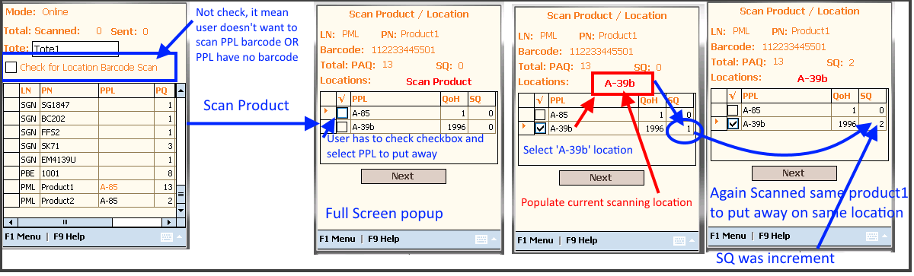
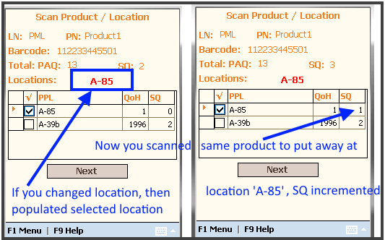
Steps :
1 – Scan Product then full screen popup will be open for select location
2 - check PPL by checking checkbox into checkbox column
3 – Then start product scan. If more then one qty then repeat product scan
4 – Once you finish one product scan Next to next product scan or back to product list page.

        - With Location barcode scan : In this option users can scan location barcodes as well as checking the checkbox of “Check For Location Barcode scan”. Checking this box enables scanning step to first Scan the part to enter the 'Barcode' and then scan the 'location barcode'. Repeat these steps for all products that the user desires to Put Away.
Steps :
          - Scan product. Full screen 'Scan product/location' popup will be open
          - Scan location. Then SQ (Scan qty) will be increment with product's barcode qty into location grid as per related PPL. Scanned location displayed on top of the Grid.
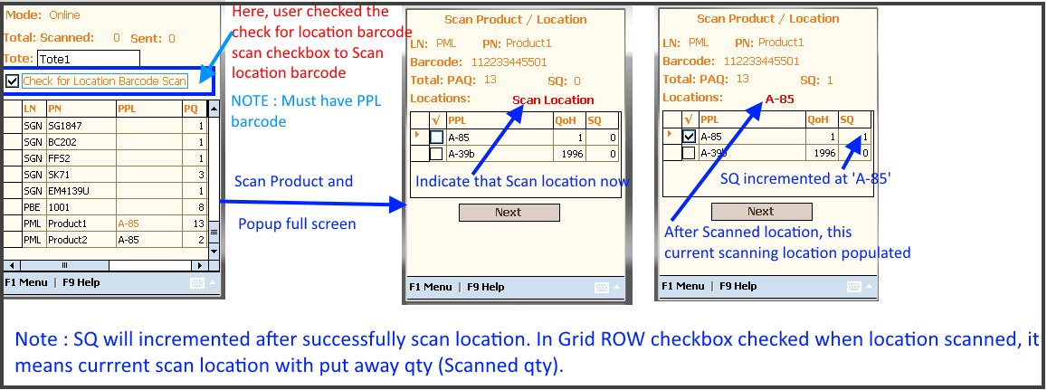
IF there are no product physical locations for this product, user want to put away product at new location then he can scan location, message popup will show up and ask to user that “That's not right location. Are you sure you want to put it there instead?”. IF YES then this location append to grid. Once 'Save' it, this product put away on this new location.
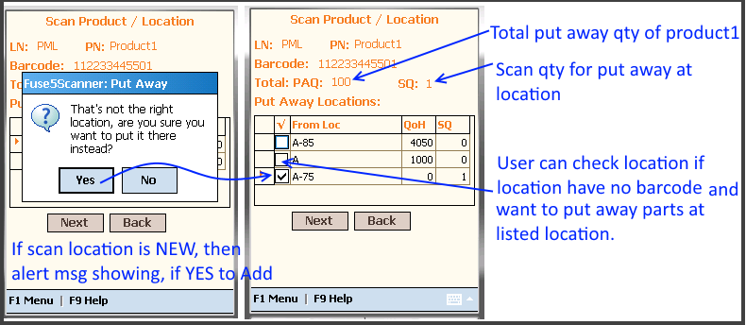
Pending in Device: This option allow user to restore the receipts from device which was previously saved on Exit from scan page.

Save into Devie:
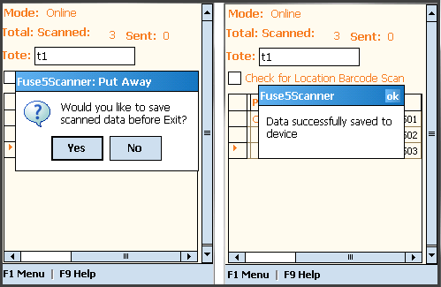
Restore from device:

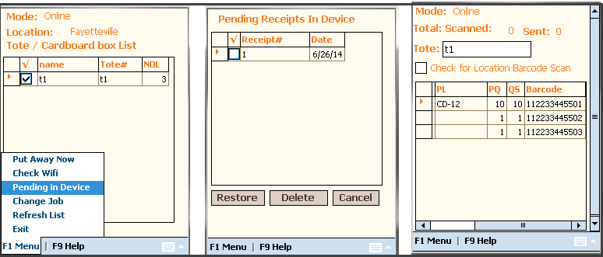

3. Fill Tote : In this action, the PIG or Put Away, can scan the parts into the tote if the receiver didn't.
Step 1: Scan the Tote you're filling.
Step 2 : Scan each part you desire to put into the selected tote. Then put it away by proceeding to the physical location (ie. tote, palette, zone/shelf/bin etc).

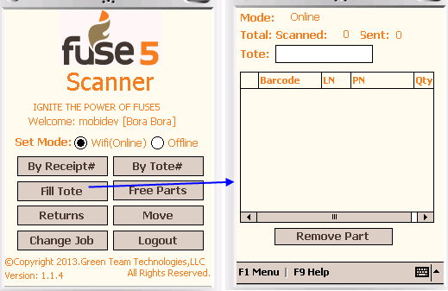
To Fill the Tote:
Step 1: Enter the tote# or cardboard box# in the Tote field. ( ie. here it's TOTE 1).
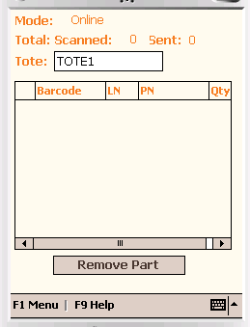
Step 2 : Scan the products to fill in this tote.
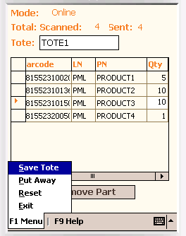
User can edit this qty

Step 3: Save the tote to proceed to the Put Away List. Here we'll tell fuse5 where everything goes and the best order to proceed through the warehouse in.

Now, move to Product Physical location
Step 4 : Put Away user can go to F1 menu. ( User can go from dashboard “Put Away” button as well.)

NOTE : Saved tote will be listed in “By Tote” list page.
At this screen, the user can view a list of the previously saved tote products by scanned tote.

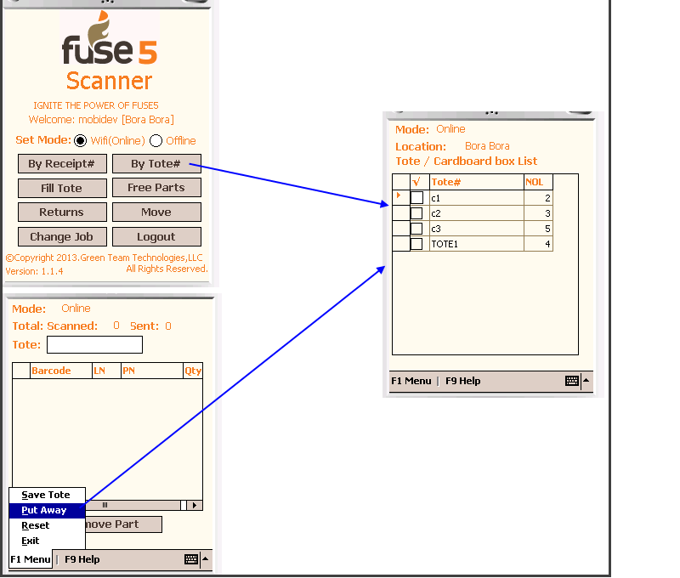
Pending in Device: This option allow user to restore data from device which was previously saved at Exit on scan page.
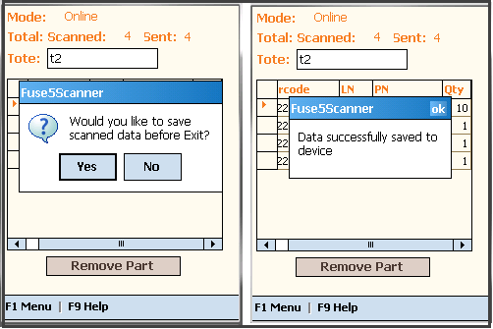
Save into Device:

Restore from Device:

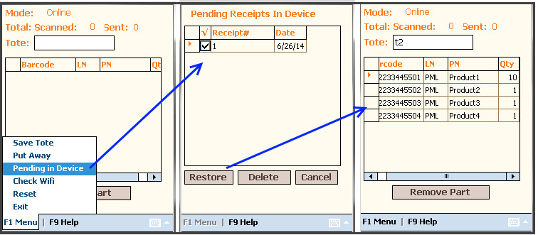

4. Free parts: A free Item or Independent Item, is an item that is not able to fit into tote. An example of a Free part is a 2-meter long steel tube so a user must be put away freely. Using this option a user can put away free items into a Physical Product Location.
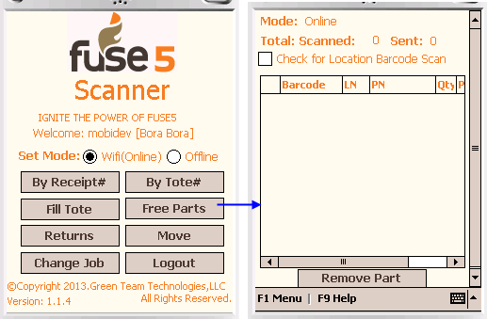
Pending in Device: This menu option allow user to restore data from device which was previously saved into device at Exit on Scan page.
Save into device:
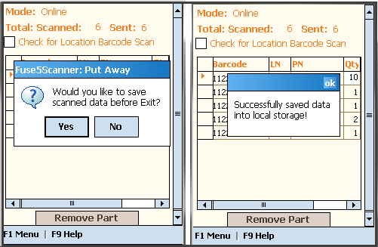
Restore from device:

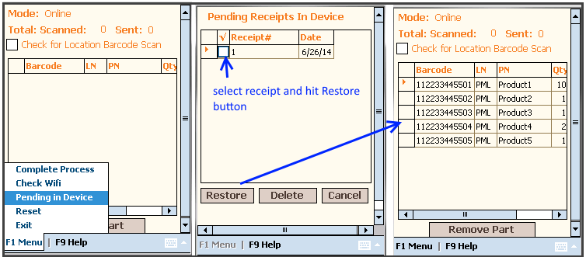

5. Returns (Put Away Returns item) : This function enables a user to scan and put away returns from Sales Orders / Store Transfer products into Physical Product Locations.

Steps to Put Away Return Items:
    - From the Main screen click on 'Returns'. This will direct the user to the Returns SO/ST list page (which displays the Sales Orders/Store Transfer returns) :

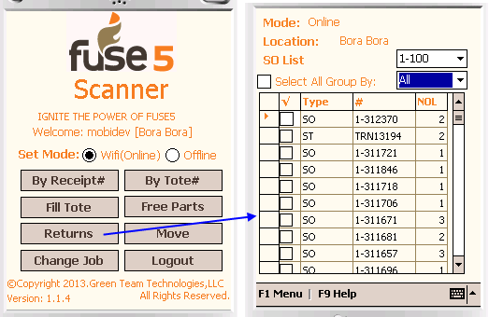

Here you can view a list of 'All' returns as well the ability to narrow your search with the dropdown by type (Sales orders or Store Transfers) by selecting SO or ST).
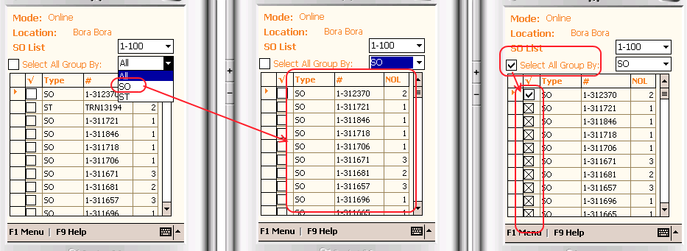
- Next action is to scan products (Without location scan)
Step 1: After you have selected the ST or SO you would like to return products for, From the F1 menu select 'Put Away Parts'
Step 2: Scan the parts. If the PL word is orange then it indicates that there is multiple Physical Locations for this part.

Step 3: After the part is scanned the Quantity Scanned is increased.
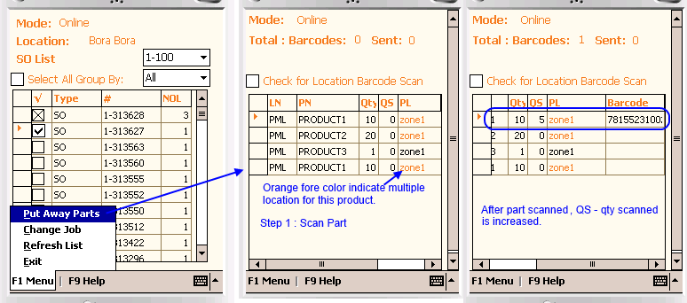
- Scan the product with scan location barcode:
Step 1: Select 'Check for Location Barcode Scan'.
Step 2: Scan the Part
Step 3: Scan the Location in the PL column cell.
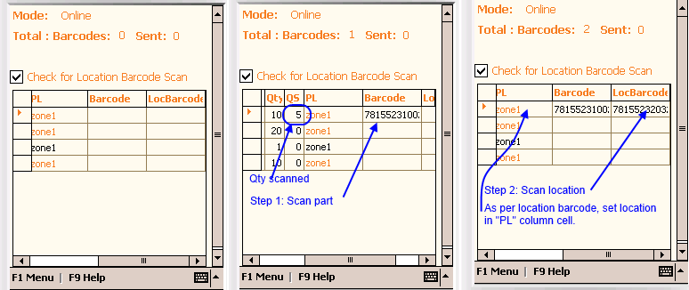

Here, user must repeat step 1 and 2 for each product.

Pending in device: This option menu option allow user to restore back data from device which was previously saved into device at Exit or Save into Device option at Scan page.

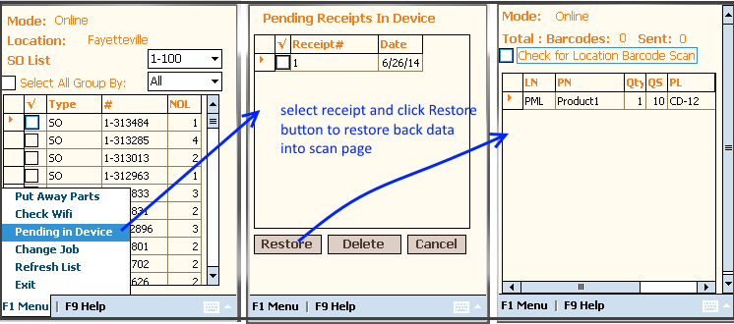

MOVE Function : This function allows the user to move parts from one location to another location in the warehouse. The terminology that is used is the old location is the From location and the new location is the To location.

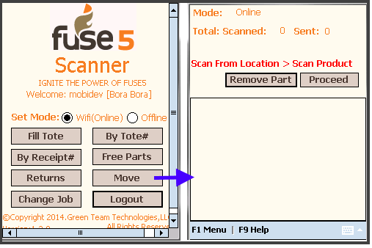

Click the 'Move' job from the main menu.
Scanner Move function: This function must be perform in 2 phase - 1. Pull parts and 2. Place parts to destination.

Pull Parts screen:

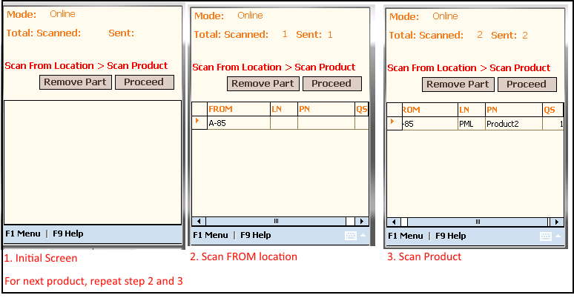
Step 2 : Scan the FROM location. This can be a tote/bin/shelf/zone. In this example we are going to use: A-85 location
Step 3: Scan the Part number barcode. The example we are going to use is Product No : Product1 with qty = 1.
After Finish pull parts and walk away to place the parts into destination by Hit 'Proceed' Button and next screen well be Place parts.

Place Parts Screen:
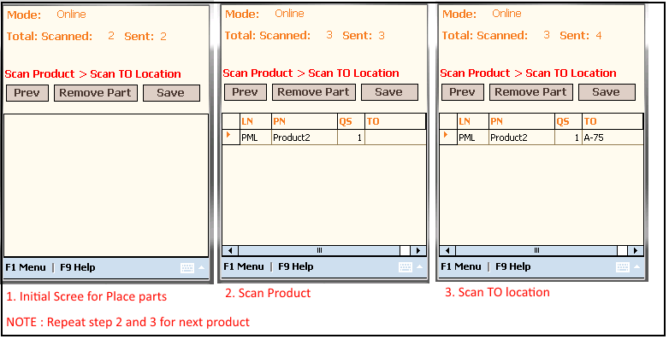
After finish moves and If in connected mode, immediately Hit 'Save' button to the updated data to fuse5 for update the inventory for real time result.

- PICKER : This job function is to pick the product from warehouse for store transfer, sales order and RGN PO and will assist a user in knowing what needs pick and from where to pick it. This is the step that updates the Product Physical Location in Fuse5 with pick location and pick qty.

Custom setting for Picker Module in Company Setting > Other Tab of Fuse5:
- WMS Location: Set 'Yes' for make WMS enable for particular location and 'No' for disable WMS.
- Pick Ticket Sort Order: This sorting applies on SO pickticket and also on ST pickticket if the global custom setting 'Store transfer product # sort options' is set to 'As per location setting'
- PickTicket Zone Source: This setting enable user to set pick ticket zone source from WMS or product's zones from product details page.

Custom setting for Picker Module in WMS & Scanner section of Fuse5:
- SO Priority Picking: When in 'Picker' Role, and either 'Pick by SO#' or 'PPV', Sales Orders will be sorted according to the priority of 'Delivery Methods'. Drag and drop 'Delivery Methods' to adjust priority hierarchy.
- Unlock Products by Role: User role to unlock products for scanner. Products are lock from scanner while user get products in scanner
- Auto Populate Pick Jobs: When logged in as the User Type 'Picker' on the scanner application, SO's will populate according to the 'Delivery Method' set at the POS, and by the hierarchy of the 'Delivery Methods' set in the Custom Setting 'SO Priority Picking'.
- Check For Location Barcode Scan: This Custom Setting applies to both 'Picking', and 'Physical Inventory' modules on the Scanner Application. Roles pushed to the right will have the 'Check For Location Barcode Scan' field checked by default when logged in as User Type 'Picker' or 'Physical Inventory' on the scanner.
- Adjust SQ On The Scanner: Select which Roles will have the ability to manually adjust 'SQ' on the scanner application.
- Show WMS Modules: Turn this setting 'ON' to restrict access to WMS modules by Role. Then push Roles to the right to give access to WMS modules in Fuse5.
- Display Pick ticket notes on scanner: Turn this setting 'ON' to restrict to role to show pick ticket note on scanner.
- Scanner Default check Pending Part Verification Out of Stock option: This setting turn 'ON' for PPV sales order part verification.
- Display 'Without PPL Physical Location' in Picker: This setting turn 'ON' for picker that display without PPL physical Location (tote/pallet/cardbox/truck) to directly pick from tote.
- Display Product Name in Picker Scan Product/Location popup: This setting enable user to set 'Check location barcode scan' by default on by turn 'ON'.

Picker Dashboard:
1. Role Screen : This screen allows users to select the PICKER role and go to PICKER Dashboard in order to achieve the picking related job functions. This screen also allows users to select Zone(s), from where user needs to pick products.
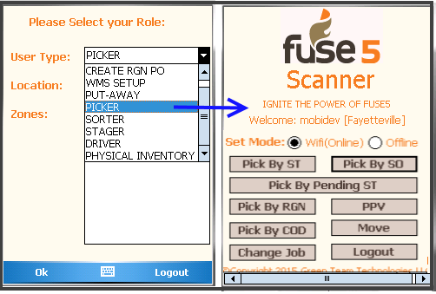

There are three type of functions of picking : Pick By ST (Store Transfer), Pick By SO (Sales Order) and Pick By Returns Good Notes (RGN).

Pick by ST : This job function allows users to pick parts of Store Transfer(s) and user will get a real time Store Transfer list.
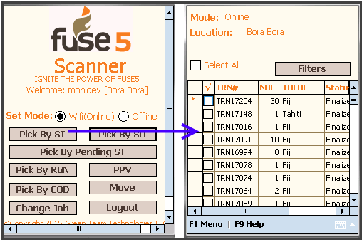
Filters: This feature give the ability to filter the picking list by TO location and particular date. To go to filter options, click on 'Filters' button on Top right corner.

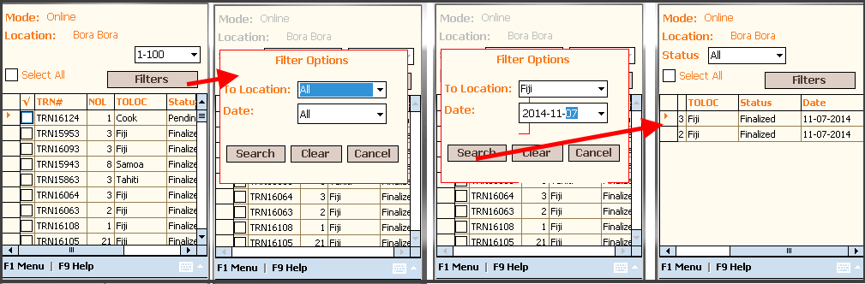
After that if user want to get default result (without filters) - just Hit Clear to clear out filter criteria and Hit Search to get all records.
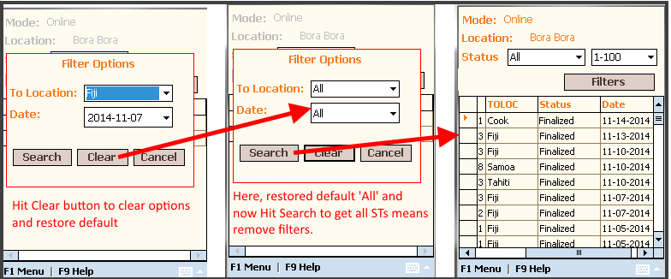
Paging: This option allow user to navigate paging with list of 100 records by select option from paging drop down.

    - Select Group of “TO” location : This function would give the user the ability to select location wise group.
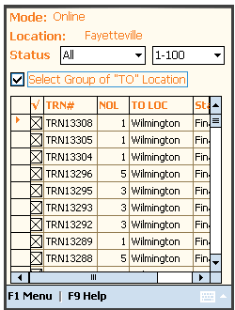
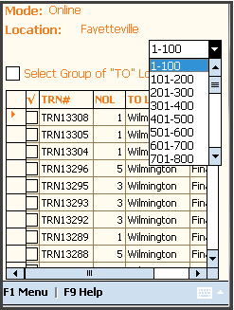
Here, we can see select all Wilmington location ST(s) with Finalized status.
NOTE :
- This group location selection all same location with first one with same status.
- Select only one status group ST(s) like only select Finalized group or select only Pending Group.

After you have selected the Store Transfers you would like to pick parts for go to F1 Menu Options :

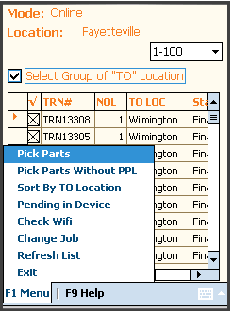
        - Pick Parts :This option enables users the ability to pick parts for selected ST(s).
        - Pick Parts Without PPL : This option is for who have not WMS. This option allow user to pick parts but do not worry about pick product physical location.
        - Already Picked: This option enable user to remove ST(s) from scanner and marked as picked.

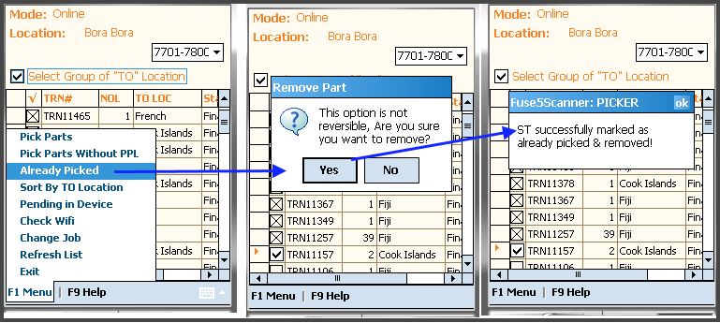
        - Sort By TO Location: This option gives users the ability to filter ST(s) by location as below:
- User will select some or all locations (ie. User will select "Raleigh" and filter result screen will look like this:
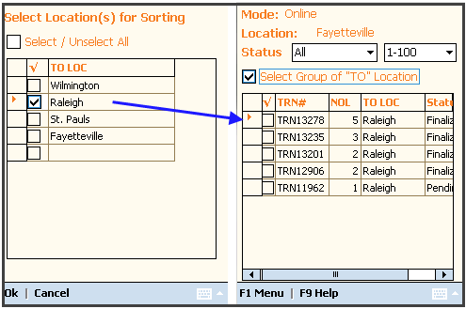
    - If User will select All locations
5. Pending In Device : This option enable user to restore device saved receipts to screen and user can save back to fuse5.
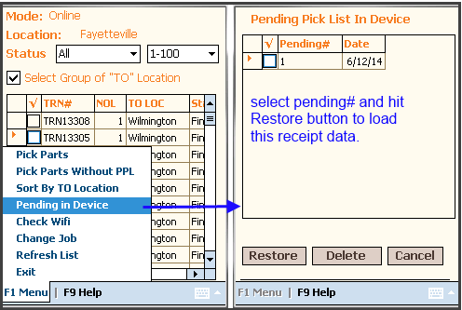

F1 Menu options:
Pick Parts: After selecting this group, users need to be pick the parts of the selected Store Transfer or ST(s), the user will be redirected to the next screen for picking parts.

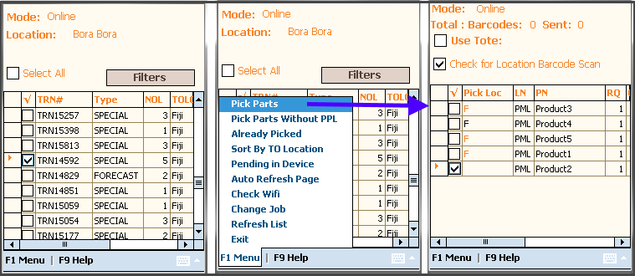
Here, We can see we have selected 1 Store Transfers and then the user clicked on “Pick Parts” option from F1 menu. The next screen displays a list of picked parts.

The user can now start the picking process using by scanning parts. In above screen shot we can see the default pick location in “Pick Loc” column. You can see that fout parts are in F location( zone: F).

Pick Parts without PPL : This option allows users to pick parts without worrying about Physical Product Location.
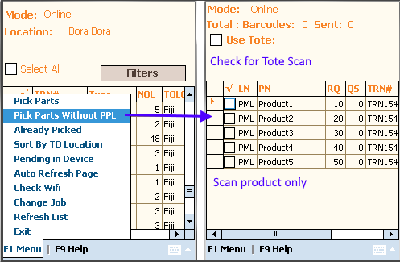

NOTE: In Pick Parts Without PPL there is no need to scan product location, the user just scans the parts.
Sort By Zone : This option allow user to pick part by zone.

Step 1 : Type the tote# or scan barcode of tote to User tote textbox at top of the screen, in which we would like to put away the picked part. This is optional for a pick on free parts. The user can uncheck the checkbox Use Tote for those products.
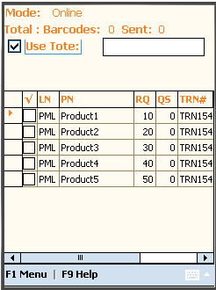
Here, the user selected the check box next to Use Tote and typed tote number in textbox or scan tote barcode.
Important :
- If the user want to put away picked parts into Tote/pallet, must check Use Tote checkbox and scan this tote first and then part barcode, or if not and bring picked part independently then unchecked it.
- If the user wants to pick free parts or independent parts (ie. 2 meter long steel pipe), then just check checkbox of free part row.

Step 2: The scan process. There are two way to pick parts
- Scan Parts with default location only ( Without location barcode option) : In this scan process, the user has to scan the part and select pick location as below
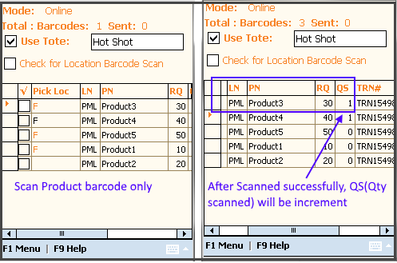

NOTE:
- If product have only one location, then it is by default set in Pick Loc.
- If you would like to pick from multi locations, just click on 'Pick Loc' column and select from list.

- Scan parts and then location ( With location barcode option) : In this scan process, the user has to scan part first and then scan the pick location. When scanning the pick location, if the pick location matches the correct location then the scanner sets it by checking location from location grid and increment pick qty (SQ) for this location.
NOTE: For enable this option, must check checkbox of “Check for location barcode scan”.

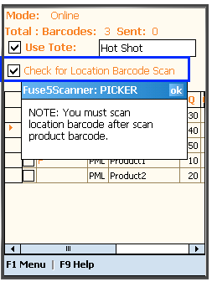

Step 1 : Scan product, it will be open full screen popup, Where product and its locations are display.
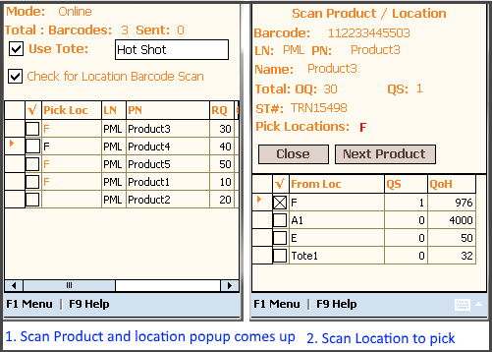
Step2 : Then scan location, if you have scanned right location then scanner select it from grid and showing into the top of grid. For same product repeat step1 and step 2.

For Next product hit 'Next product Scan' button and it will display next product from grid and user can directly repeat Step1 and Step2 to scan. No need to close this popup. After finish all products scanning, user close this popup by hit 'Close' button and back to product grid.
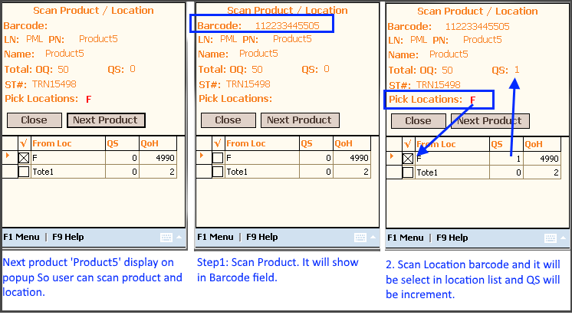
After Finish scanning, user can sync the data into Fuse5 by F1 Menu >> complete process.
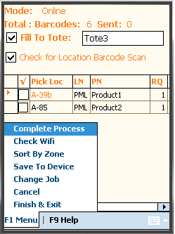
F1 menu:

- Complete Process : This action updates the inventory of fuse5.
- Check Wifi: This option allow user to check that scanner is connected with wifi or not.
- Sort By Zone : This is used to Filter the list by zones.
- Save to Device: This option enable user to save scanned data as pending in Device.
- Change Job : Allows the User to switch jobs.
- Cancel: Using this functionality a user can cancel the screen and go back to List page.
- Finish & Exit : Using this function use can exit from this process but at this function user can save last scanned items as pending while exiting.
Cancel remaining item at Pick By ST: This option allows the user to cancel remaining item after user picked.
It's like this.
For our example there is a Store Transfer with 10 line items for 1 qty each. The user goes to the warehouse only is count 7 parts. After the User finalizes, (finalize the picking of the ST), then the user is directed to the list of remaining parts that still need to be picked. The user found 7 out of 10 of the items. In this case, when the user finalizes the Store Transfer, it shows that there are 3 remaining that the user doesn't have to transfer. If the User tries to finalize WITHOUT finding those, then they will get a pop-up that says "Cancel remaining items from the ST" Yes/No.

If the User selects YES, then the Store Transfer is updated in Fuse5 by canceling those items, so the TO store now is only expecting to get these 7 items picked. If the user selects NO, then we're still only shipping 7 items to the TO, BUT other 3 items are still expected to be shipped at another time. They remain on the Store Transfer as not yet received.
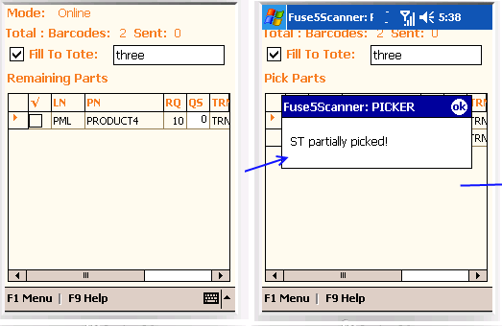
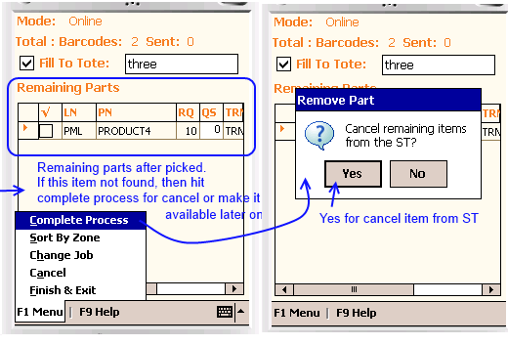
Pick By Pending ST: This job function allows users to pick parts for pending Store Transfer(s) and finalize it and user will get a real time Store Transfer list.
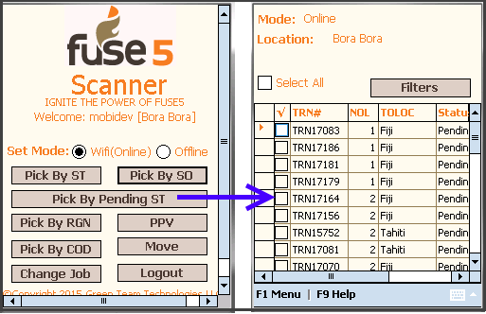
Filters: This feature give the ability to filter the picking list by TO location and particular date. To go to filter options, click on 'Filters' button on Top right corner. (As above in Pick By ST).
Paging: This option allow user to navigate paging with list of 100 records by select option from paging drop down.

Select All: This checkbox allow user to select/unselect all store transfers from list.
After you have selected the Store Transfers you would like to pick parts for go to F1 Menu Options :
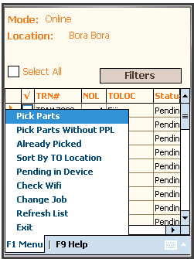
1. Pick Parts :This option enables users to pick parts by scan parts for selected ST(s).
2. Pick Parts Without PPL : This option is for who have not WMS. This option allow user to pick parts but do not worry about pick product physical location.
3. Already Picked: This option enable user to remove ST(s) from scanner and marked as picked.
4. Sort By TO Location: This option gives users the ability to filter ST(s) by location as below:
5. Pending In Device: This option allow user to restore saved receipt from device storage database.
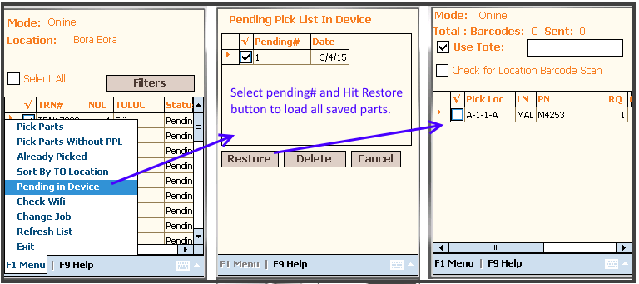
Pick Parts: After selecting this ST(s), users need to be pick the parts of the selected Store Transfer or ST(s), the user will be redirected to the next screen for picking parts.
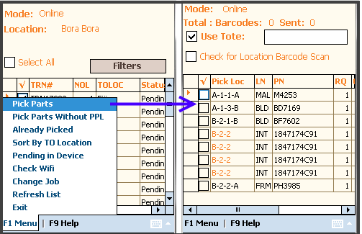
The user can now start the picking process using by scanning parts. In above screen shot we can see the default pick location in “Pick Loc” column.

Finalize completely Picked Pending ST: This feature allow user to directly finalize pending ST which were completely picked previously.
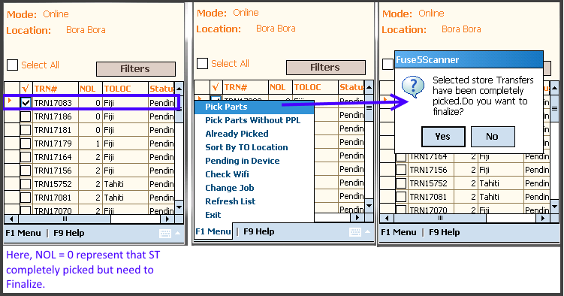
NOTE : Authorized user can finalize this pending ST only.

Pick By ZONE : This feature allow user to pick parts by zone. User can pick only certain zone by filter list by zone in two ways :

- Select certain zone from 'ROLE/ZONE SELECTION PAGE' after Login screen.
- At Pick Parts screen F1 Menu >> Sort by Zone
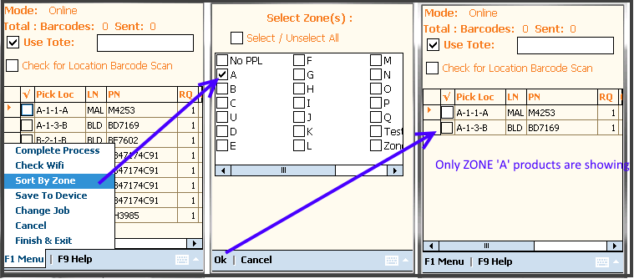
After finish all scanning, user Save or Finalize this ST into Fuse5 by F1 Menu >> Complete Process.
F1 menu:

1. Complete Process : This action updates the inventory of fuse5.
2. Check Wifi: This option allow user to check that scanner is connected with wifi or not.
3. Sort By Zone : This is used to Filter the list by zones.
4. Save to Device: This option enable user to save scanned data as pending in Device.
5. Change Job : Allows the User to switch jobs.
6. Cancel: Using this functionality a user can cancel the screen and go back to List page.
7. Finish & Exit : Using this function use can exit from this process but at this function user can save last scanned items as pending while exiting.

Validate pending ST discrepancy : This option allow user to verify discrepancy after finish scanned for validate if all products qty found or not in physical location. If some product qty was not found then, scanner will popup to show the discrepancy list to verify and update ST order qty or leave it for later on picking.

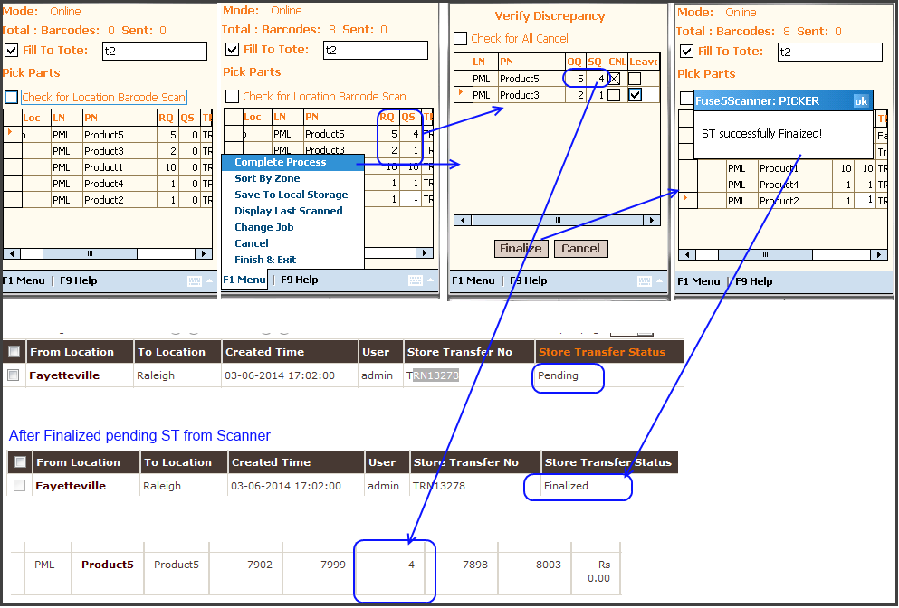
Check 'CNL' column checkbox if user want to update transfer qty into ST or check 'Leave it' column checkbox if then want to check this product again into warehouse and pick if found. Then user hit to 'Finalized' button to save this updated ST into Fuse5 back.

NOTE : Only authorized user can cancel or finalize pending ST.

Pick By SO: In this job function users will use Sales Order (SO) numbers. This job function contains a real time list of Sales Orders SO(s).
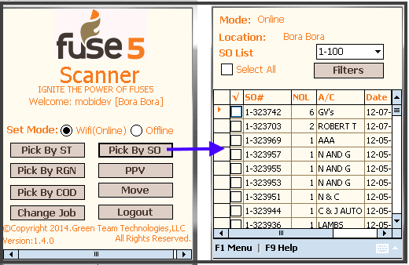
Pick By COD : In this job function users will use COD(Cash on Delivery) Sales Order (SO) numbers . This job function contains a real time list of COD Sales Orders SO(s).
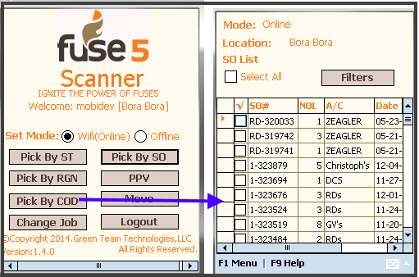
NOTE : All functions and features are same as Pick By SO.

Filters : This feature allow user to filter the pick list of SO by Account and Date.
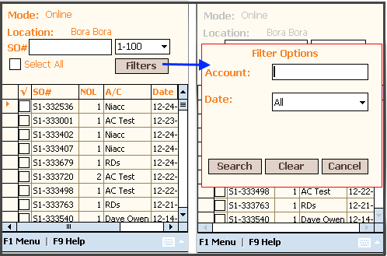
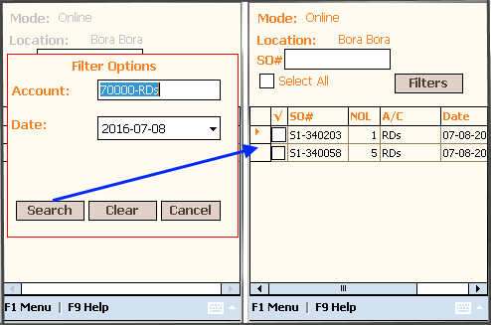
Here, Also remove filters and get all records, just Hit Clear button to clear our filters and Hit Search with All.

This Sales Order (SO) list allows users to select a group of Route locations by checking the checkbox next to the desired Sales Order #.
Select All Check Box: To select all records from grid to pick.

1 Sort By Route: This option gives users the ability to filter Sales Order(s) by Route as below:
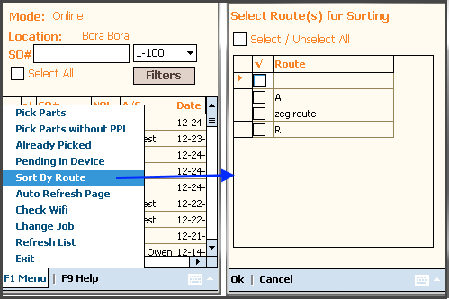

- The User will select some or all routes on by putting a check in the box next to the route (ie. User selected "Zeg Route" and filter result screen will look like this:
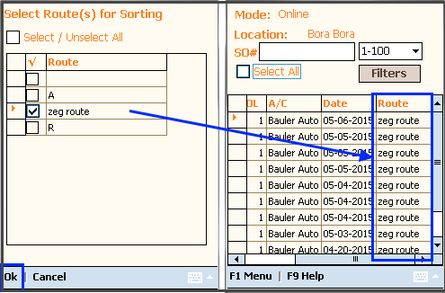
- If the User selects All routes by checking the box next to Select/Unselect All then all routes will be
displayed .

Pick Parts: After selecting this group, user needs to be pick parts of selected SO(s), so user has to redirect at next screen for picking parts.
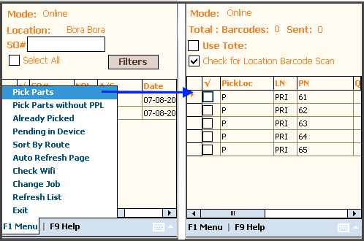
Here, We can see 1 Sales Order is checked and “Pick Parts” option was chosen from the F1 menu. The next screen will display a list of pick parts.(ie. 5 parts needs to be picked for the selected Sales Order.
Pick Parts without PPL : In this option, do not worry about pick location, just scan only parts.
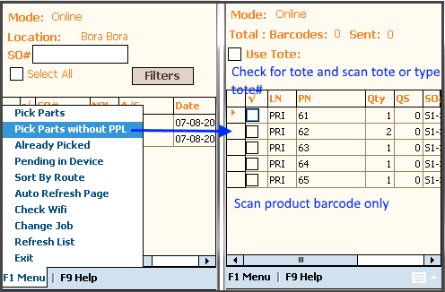

Next, the user will start the picking process by scanning parts. In above image we can see default pick location in “Pick Loc” column.

Step 1 : Scan the barcode or type tote# in the Use tote# textbox at top of the screen. This should be the location in which we would like to put away picked parts. This is optional for free parts.

Important :

- If the user wants to pick free parts or independent parts (ie. 2 meter long steel pipe), then select the checkbox next to the LN column free parts row.

- Leave this Unchecked if you desire to pick the tote. (ie. If only one item or only one free item)

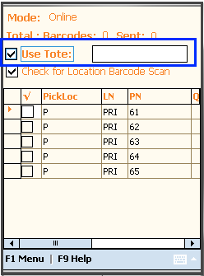

Step 2: Scan process : There are two way to pick parts Scan only Parts with Default Location and Scan the Part and then scan the location.

- Scan only the parts with default location ( Without location barcode option) : In this scan process, the user is required to only scan parts and does not need to scan the pick location. The default is set as per below.

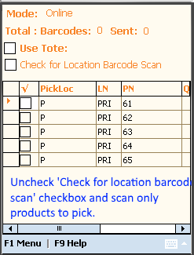

ie. Here the default pick location for product '61' is 'P' zone. If the user clicks on the orange Pick location in the Pickloc field, a popup appears with multiple locations with Qty on Hand. The User can select one of them to set default pick location.

Now Scan the product :
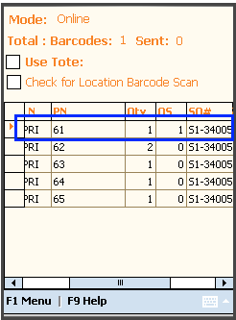

Here, we needs to be pick product '61' part with Qty = 1 so the user scanned these parts. The scanner will set the QS or Quantity Scanned with the barcode qty and fill barcode for the appropriate product. If the user scans the same product then scan qty (QS) will increase incrementally.

For the next product the user scans the product then scans the scanner set barcode for this product row.

    - Scan part and then scan location ( With location barcode option) : In this scan process, the user has to scan the part first and then they must scan the pick location. When scanning the pick location, if it is correct location then the scanner must set the location name in “Pick Loc” column and barcode in “Loc Barcode” column.

NOTE: For enable this option, the user must check the checkbox of “Check for location barcode scan”.

Step 1 : Scan product

Here, the Barcode column cell has been fill by the scanned product barcodes and the row pointer has been set at the matching product row from the list.

Step 2: Scan the Location barcode

Here, we can see the scanned location barcode has been filled in “LocBarcode” column cell and QS : Qty scanned was increased incrementally. For each product, the user must repeat step 1 and 2.
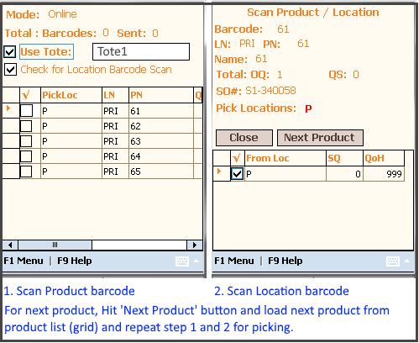

After Finish scanning, the user can sync the data into Fuse5 by F1 Menu >> complete process.
F1 menu:
- Complete Process : This action updates the inventory of fuse5.
- Notify Shortage: This option enable user to check shortage while picking items and notify it to counter parson of Fuse5.
- Sort By Zone : Is used to Filter list by zone.
- Save to Device: This option allow user to save scanned data as pending into device.
- Change Job : Is Used to navigate to other job functions.
- Cancel: Using this functionality the user can cancel the screen and go back to List page.
- Exit : Using this function a user can exit from this process. At this function the user can save last scanned items as pending while exiting.

Notify Shortage: From F1 menu option 'Notify Shortage' or while completing process, user check and notify shortage SO(s) part's ship qty to counter person of Fuse5.
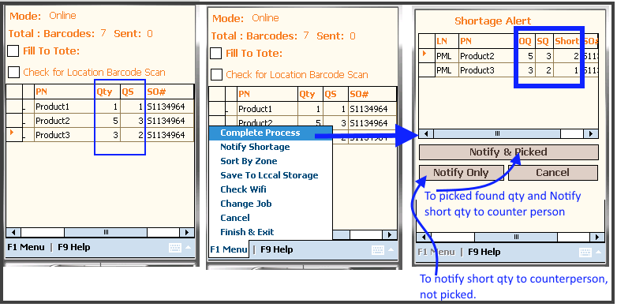
Here, We can see shortage popup with short qty so we can know how many are shortage for which product as well as we can see two more button 'Notify & Picked' and Notify Only.

Notify & Picked : This option enable user to notify shortage to counter person as well as picked scanned qty from warehouse inventory.

Notify Only : This option give ability to use to notify only shortage to counter person, no worry about pick from warehouse inventory.

Another way to notify shortage:
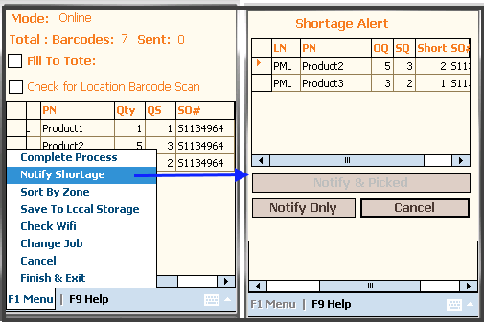
Pending In Device : This option enable user to restore device saved receipts to screen and user can save back to fuse5.

Step1 : Select 'Pending In Device' menu option from SO List Page's F1 menu
Step1: Choose one pending# and hit restore this pending back to screen.
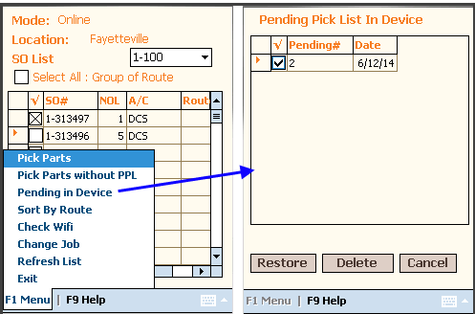
Already Picked: This option enable user to remove SO(s) from scanner and marked as picked.

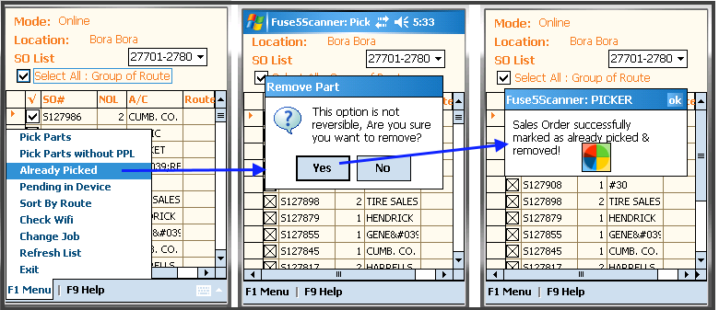

PPV (Pending Part Verification): This job function allow user to finalized and pick PPV sales order by scan/verify ship qty. At this screen the user will get a real time list of PPV sales orders.

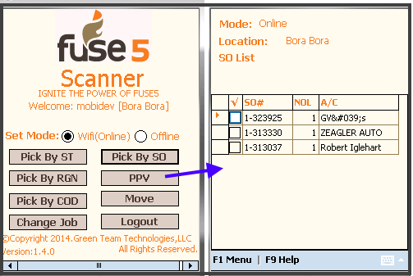
This sales order list allow user to select one of order and finalize it by checking the box next to the SO# number.

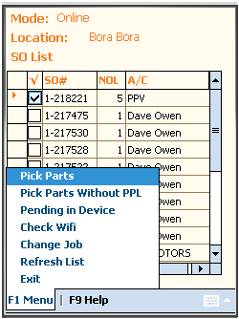
F1 Menu options:

- Pick Parts: After selecting sales order, the user is required to be pick parts of selected SO. The user will then be redirected to the next screen for picking parts (Scan parts).

Pick Parts without PPL : In this option, do not worry about pick location, just scan only parts.
Here, We can see 1 Sales Orders are checked and “Pick Parts” option was chosen from the F1 menu. The next screen will display a list of pick parts.(ie. 5 parts needs to be picked for the selected Sales Orders.

Next, the user will start the picking process by scanning parts. In above image we can see default pick location in “Pick Loc” column.
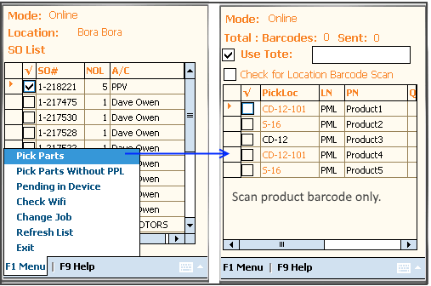
Step 1 : Scan the barcode or type tote# in the Use tote# textbox at top of the screen. This should be the location in which we would like to put away picked parts. This is optional for free parts.

Important :
- If the user wants to pick free parts or independent parts (ie. 2 meter long steel pipe), then select the checkbox next to the LN column free parts row.
- Leave this Unchecked if you desire to pick the tote. (ie. If only one item or only one free item)

Step 2: Scan process : There are two way to pick parts Scan only Parts with Default Location and Scan the Part and then scan the location. If user want to scan location baracode as well then he must check checkbox of Location baracode.
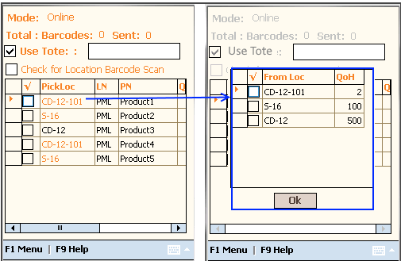

ie. Here the default pick location for product1 is 'CD-12-101'. If the user clicks on the orange Pick location in the Pickloc field, a popup appears with multiple locations with Qty on Hand. The User can select one of them to set default pick location.

Now Scan the product :

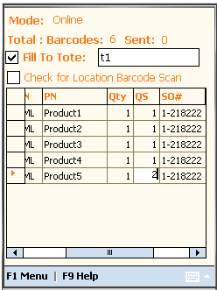
Here, we needs to be pick Product1 part with Qty = 1 so the user scanned these parts. The scanner will set the QS or Quantity Scanned with the barcode qty and fill barcode for the appropriate product. If the user scans the same product then scan qty (QS) will increase incrementally.

For the next product the user scans the product then scans the scanner set barcode for this product row.
- Scan part and then scan location ( With location barcode option) : In this scan process, the user has to scan the part first and then they must scan the pick location.

NOTE: For enable this option, the user must check the checkbox of “Check for location barcode scan”.

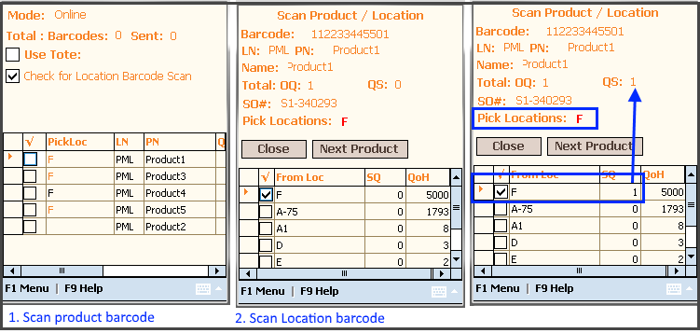
For Next product scan, just hit 'Next Product' button and next product load into this popup for scan from grid and then user can again scan that product and scan location.

After finish all scanned, user go for Finalize this sales order
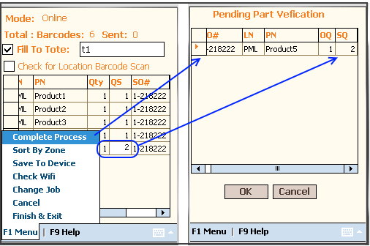
After all scanned finish, PPV validation popup comes up when user scanned more qty or less qty then original ship qty, we see last screen which listed over scanned parts, in this popup user can edit SQ and make it equal to OQ.
If user tried Finalize with greater scan qty with OQ or less scan qty then scanner showing alert message like below:

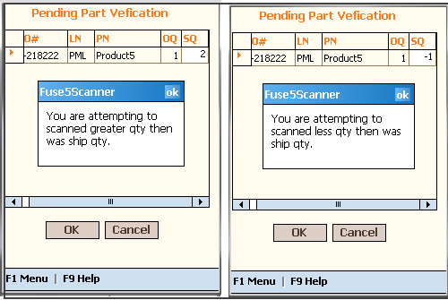
After everything fine meas scan qty will be equal to OQ, then SO will be finalize in Fuse5.

F1 Menu:
- Sort By Zone : Is used to Filter list by zone.
- Save to Device: This option allow user to save scanned data as pending into device.
- Change Job : Is Used to navigate to other job functions.
- Check Wiif : This option allow user to check scanner connect with wifi or not.
- Cancel: Using this functionality the user can cancel the screen and go back to List page.
- Exit : Using this function a user can exit from this process. At this function the user can save last
scanned items as pending while exiting.

Pending In Device : This option enable user to restore device saved receipts to screen and user can save back to fuse5.

Step1 : Select 'Pending In Device' menu option from SO List Page's F1 menu
Step1: Choose one pending# and hit restore this pending back to screen.
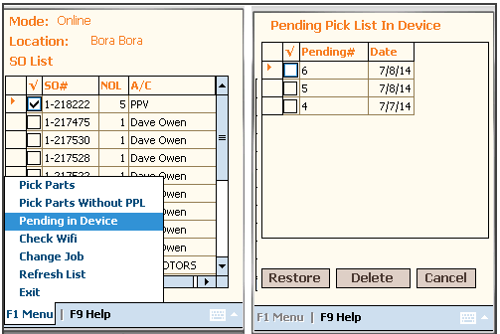
Pick By RGN :This job function allows user to pick products by RGN PO(s) or Return Good Number Purchase order. At this screen the user will get a real time list for picking.
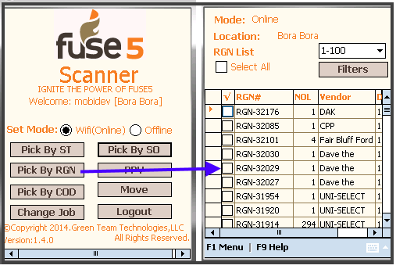
Filters: This feature allow user to sort the picking list by Vendor and Date.

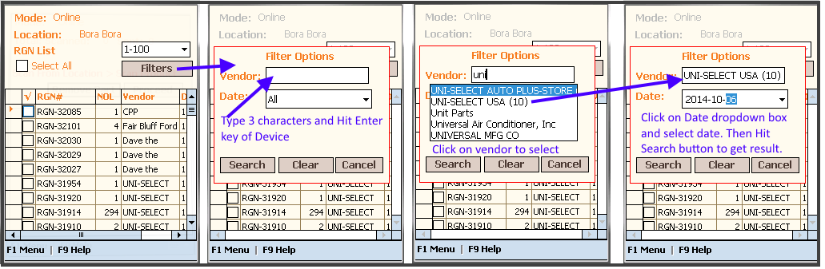
After that if user want to get default result (without filters) - just Hit Clear to clear out filter criteria and Hit Search to get all records.

This RGN # list screen allows users to 'Select All: To select all the vendors or individual RGNs by checking the box next to the RGN number.

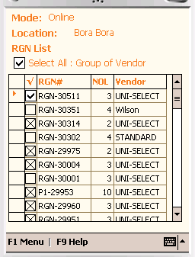

1 Sort By Vendor: This option gives users the ability to filter RGNPO(s) by location as below:
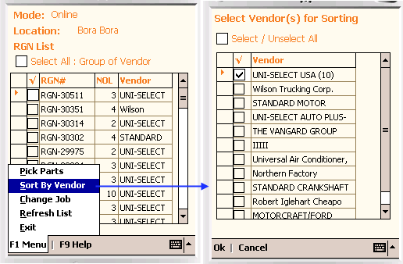
For example, the user selected the checkbox of Select All, then the user can select all RGNPO of “UNI-SELECT” vendor.
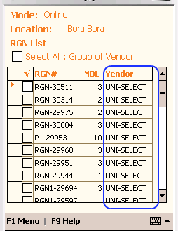
- The User is then able to select some or all of the RGNs. ie. User will select "UNI-SELECT" and filter result screen will look like this:

2. Pick Parts: After selecting this group, the user is required to be pick parts of selected RGNPO(s). The user will then be redirected to the next screen for picking parts.

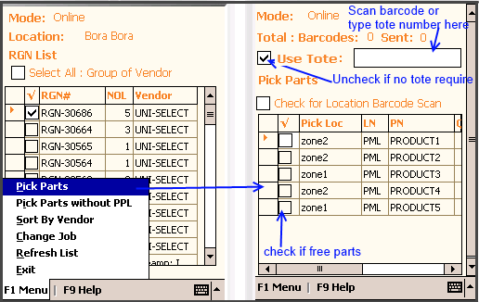

3. Pick Parts without PPL: This option allows users to pick parts without Product Physical Parts Location setup.
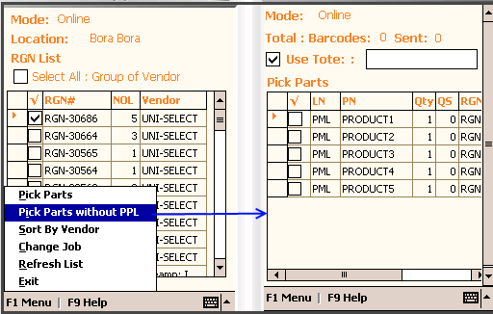

Here we can see one RGNPO has been selected. The user clicked on “Pick Parts without PPL” option from F1 menu. The next screen will display with a list of picked parts.(ie. 3 parts need to be picked for the selected RGNPO).

The user will now start the picking process using scan part. Note: in the below screen shot we can see the default pick location in “Pick Loc” column.

Step 1 : Scan the tote barcode or type tote# in Fill to tote# textbox at top of the screen. This should be the location in which we would like to put away picked parts. This is optional for free parts.

Above the user has been entered tote# : TOTE1
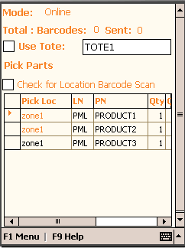

Important : If the user wants to pick free part or independent parts (ie. 2 meter long steel pipe), then there is no need to enter a tote#, this allows the parts to move independently.

Step 2: Scan process : There are two ways to pick parts, scan parts with default location only and scan the part and then scan the location barcode.

1. Scan part only with default location ( Without location barcode option) : In this scan process the user has to scan the parts only and do not need to scan pick locations, it is set as default as below.

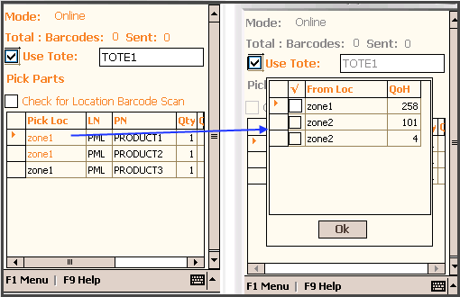

ie. Here the default pick location for product1 is Zone1. If the user clicks the location name then a popup will appear with multiple locations and Qty on Hand. The User can select one of them to set default pick location.

Now Scan the product :
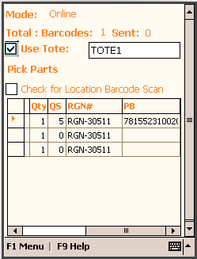

Here, we are going to pick Product1 part with Qty = 1. The user scanned the parts and then the scanner will incrementally increase the QS with barcode qty and fill barcode for appropriate product in PB (Product barcode) column. If the user will scans the same product again then scanner will increment Scan qty (QS).

2. Scan part and then location ( With location barcode option) : In this scan process, the user has to scan the part first and then scan the pick location. When scanning the pick location, if its matches what is in fuse5 then the scanner will set the location name in Pick Loc column and barcode in Loc Barcode column.
NOTE: For enable this option, must check the box “Check for location barcode scan”.
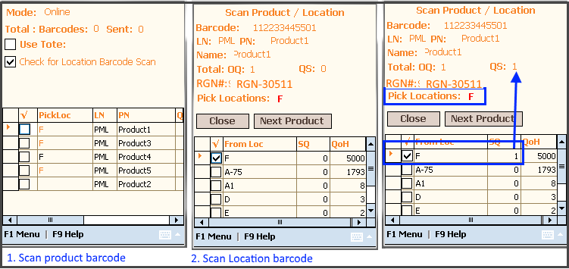
Scanning Flow : Scan product and scanner will open popup for location barcode scan. Where you will scan location barcode. Later for next product, you just hit 'Next Product' button and load next product for scan from product list and user can scan product part and location.

After scanning is completed, the user can sync the data into Fuse5 by F1 Menu >> complete process.
F1 menu:

- Complete Process : This action updates the inventory to fuse5.
- Sort By Zone : To Filter the list by zone.
- Change Job : Go to another job function.
- Cancel: Using this functionality a user can cancel the screen and go back to List page.
- Exit : Using this function the user can exit from the current process. At this function the user can save last scanned items as pending while exiting.

4 Pending In Device : This option give ability to user to restore saved pending picked into device. This option showing the last 3 receipts to give choice to user which pending receipt he want to restore.
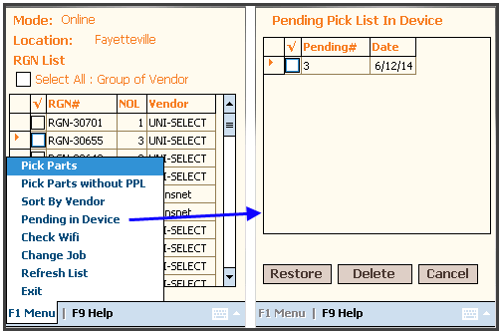
Select 'Pending#' and hit Restore button to restore scanned data from device into screen.

- Already Picked: This option give user ability to remove RGN PO(s) from scanner list page and marked as picked.
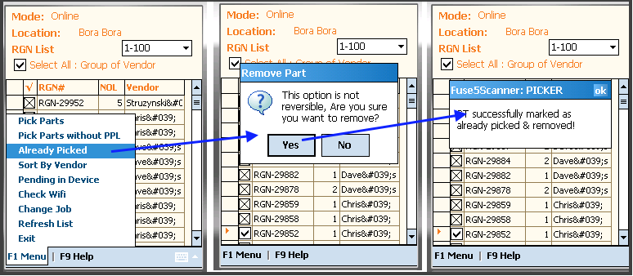
5. SORTER : This job consists of receiving the tote from the picker, sorting all parts [sorting means scanning each part in the tote] and then the scanner app tells him the route, TO Location, Vendor, purpose of this part and priority of this part into piles by ROUTE/Truck.

Main Page: The user will select the User Type: Sorter and the Location and zones to use the job function Sorter.
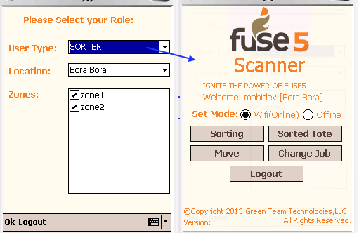

1. Sorting: From the main Sorter Screen select Sorting. Type in the 'From tote' box the tote#, which was filled from the PICKER and Select Enter key to list the parts for sorting.
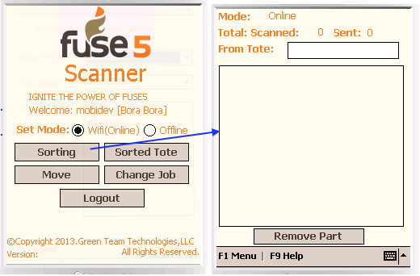

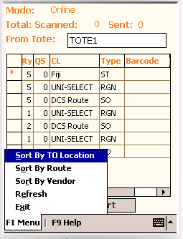
F1 Menu options:
- Sort By TO Location: This functionality gives the user the ability to filter products by TO location (CL)
- Sort By Route : This function gives the user the ability to filter the products list by Route.
- Sort By Vendor : This function gives the user the ability to filter the products list by Vendor.

Sorting process : First scan the parts to be moved and then scan the location the user intends to move or put away for packing and location. This can be a tote, cardboard box and palette.

Step 1 : Scan Product

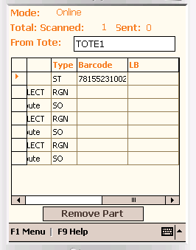
Here, the user has scanned “Product1 (Barcode 781552310020)” which is in the first row, so the cursor is set to the first row.

Step 2: Scan TO location: now the user will scan TO location (where to move the part to).

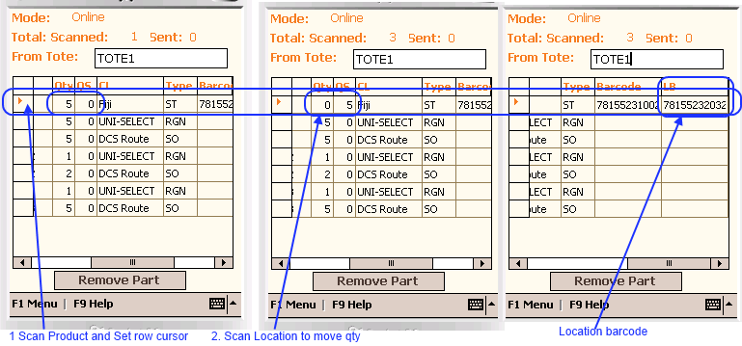
Here, after the Location is scanned, the Scanner moved product's barcode qty to move TO basket.
ie. A user can scan Product1 and its barcode qty is 5 then Qty will be Qty – Barcode Qty ( 5 -5 =0) and QS will be 5.

Case 1: Product1 have Qty 50, and user wants to move 20 qty into location1 and 30 qty into location2. In this case the user must scan product 1 for Location1 as well as for location2.

NOTE : For next product must repeat step 1 and step2

Important: In this scan process, 1 round trip (meaning Scanning the Product and Scan the Location) will finish and the qty will immediately reflect to fuse5.

6 STAGER : This job function is used to consolidate totes for the same location that come from different zones. In this job function the user will merge totes for the same location and load the floor for the truck.

Page 1 : Stager dashboard
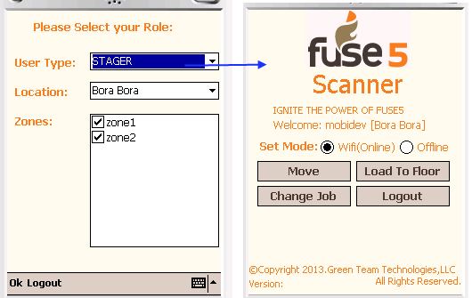

1. Load To Floor : In this function, the user will scan the part and type the final floor name to load item onto the Floor.

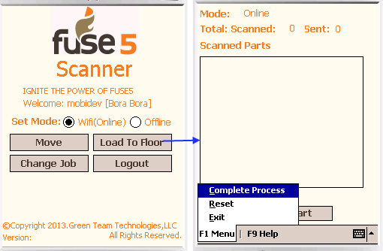

Scanning process :

Step 1 : Scan the part (ie. Product1) and Edit Qty

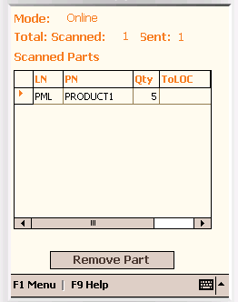

Step 2 : Type the TO location into the ToLOC column (floor ie. A)

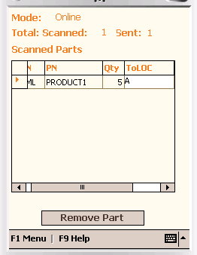
Repeat Step 1 an Step2 for each product load.

After the User is finished scanning, sync the data to Fuse5 using F1 menu >> Complete Process.

7 PHYSICAL INVENTORY (PI): This job function is used to reconcile products in fuse5 physical inventory by PPL location or by product line code.
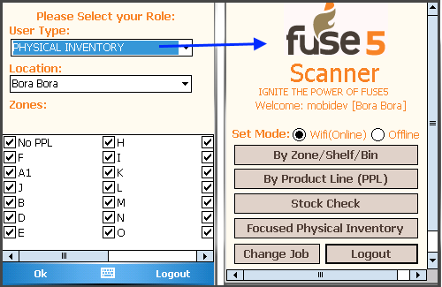
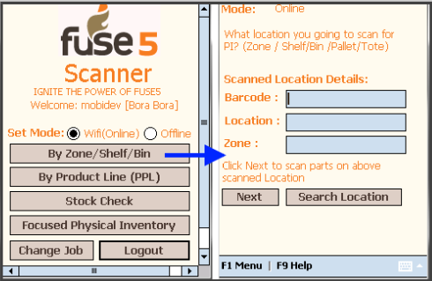

By Zone\Shelf\Bin : On this page, the user scans the location for which location he going to reconcile. ie. if he would like to scan shelf 1 of zone1 then scanner can display location name with its zone as below:

After Scanned location, (ie. zone1)

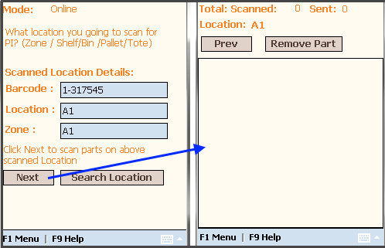
If the warehouse doesn't have a location barcode, then the user must search locations by keyword. In the example below to find zone 1, 1 was typed in the Keyword field (same as search in PPL in Fuse5) as below:

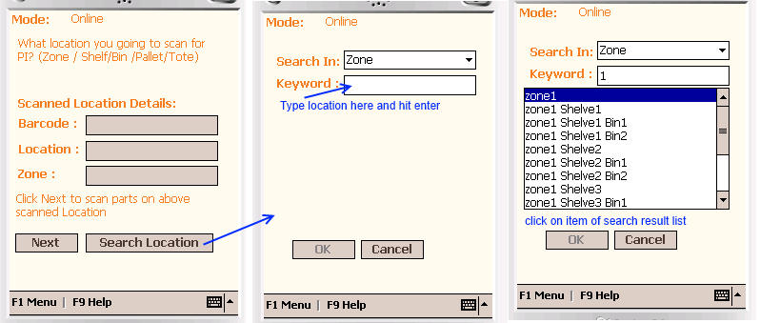
Here, the user can select search type as well such as selecting to search in zone, shelf, bin or tote/pallet.
Important: If zone/shelf/bin/tote/palette name is numbered in Fuse5 WMS then the user must type the number in the search keyword textbox to search.

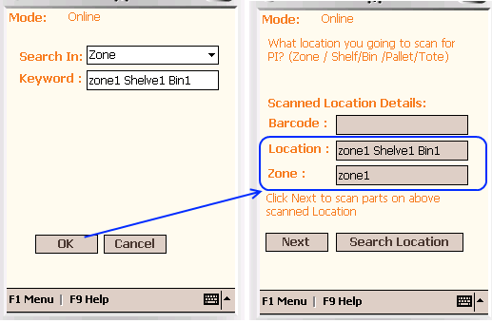
After the user has completed their search for location, hit the next button to go to Scan page for this location.

Now, start scanning all parts for Shelve1.

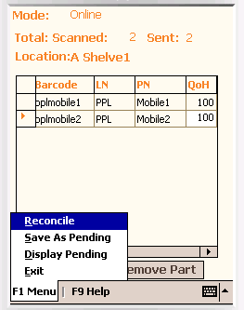

After the scan is completed, the user can select Reconcile from the F1 menu to send this data to fuse5 for a physical inventory adjustment.
Save As Pending - From the F1 Menu the user has the option to Save and would like to do reconcile later on. Then they can choose "Save as Pending" to save data into device local storage.
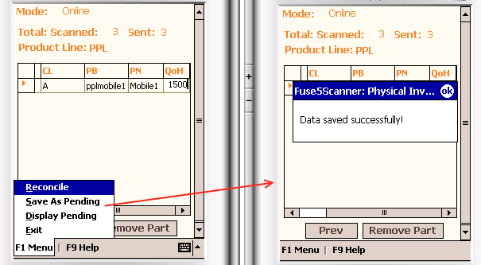

After the user Saves as Pending, the user can Reconcile the locally stored data by selecting "Display Pending" option from the F1 menu screen as seen below:

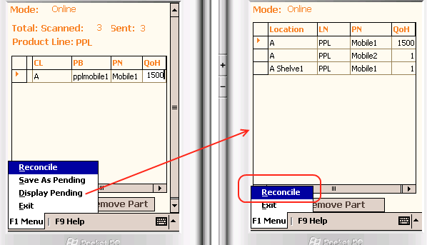

Pending in Device: This menu option allow user to restore back from device which was previously saved into device.

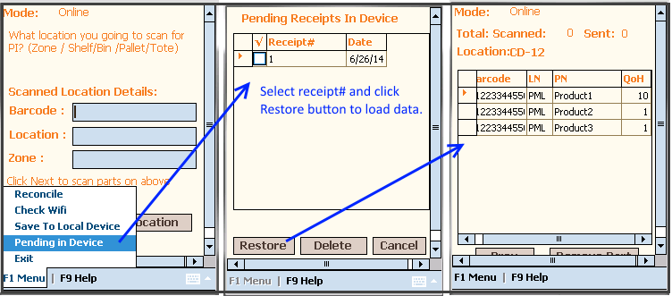
- By Product Line Page : On this page the user can select linecode from auto suggest list or scan any parts from the linecode's product they would like to reconcile as below:

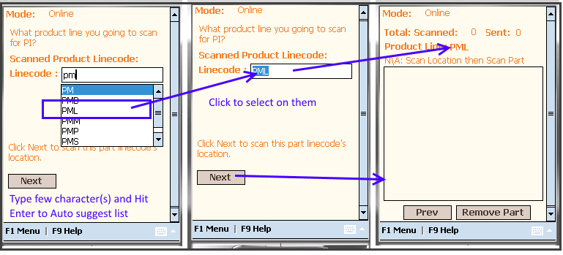
Here a user entered linecode "PPL" or if they would like to take the linecode directly from the product, then the user can scan any product of the linecode PPL (ie. Pplmobile1). The scanner will then display the linecode in the textbox.

After this is complete then the user can scan all products with this linecode in warehouse so first scan location and then product.

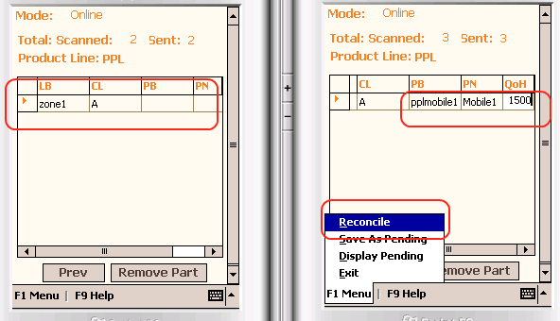
When the user is finished with scanning, to reconcile this scanned product at a particular location in the warehouse and send it to fuse5 for Physical inventory report. Select Reconcile from the F1 Menu.
Important:
In Fuse5, this can be achieved by the module : Product Management->Products->WMS -> Physical Inventory (PPL) .

Pending in Device: This menu option allow user to restore back from device which was previously saved into device.

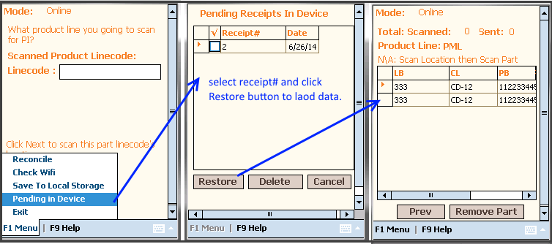

Stock Check: This function gives the user the ability to do a Physical Inventory by scanning products. The scanner will display the quantity on hand and then update the qty and sync QoH with the Fuse5 Inventory as well as keeping the entry in the fuse5 product tracker and QB integration.

Main Page: Select from auto suggest list by enter few character(s) and hit enter to populate list and Hit Next button to Go to Scan product page
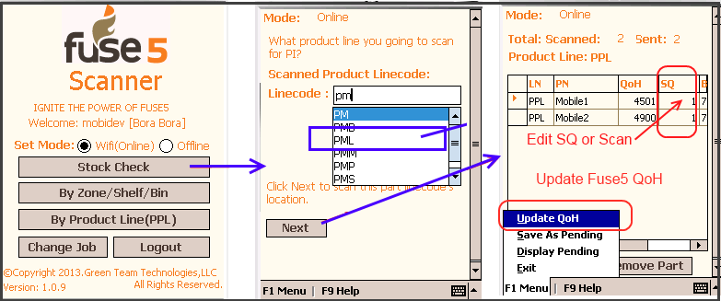

Page 2: Scan Parts and Edit SQ (Scanned Qty) either by changing qty, OR by scanning the multiple of the quantity. IE. If you have 2 scan twice.

Here, QoH means its showing currently stock on hand in Fuse5 and it is read only. So the user can compare what is in Fuse database(QoH) and what is actually scanned (SQ).

After the user has completed all scans, sync the data to Fuse5 from the F1 Menu.
F1 Menu- Select Update QoH to update qty on fuse5 and then we can see entry in PRODUCT TRACKER report as well made QB entry.

Pending in Device: This menu option allow user to restore back data from device which was previously saved into device.

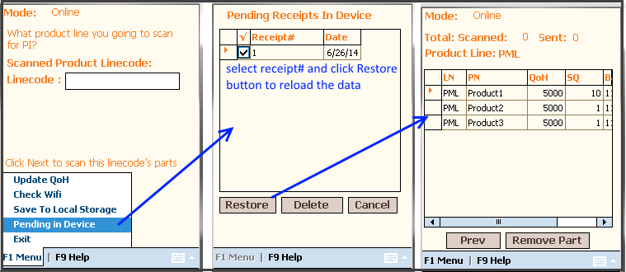
Focused Physical Inventory: This is the one more option for physical inventory that enable user to create physical inventory by give some name and send it to scanner for reconcile. The scanner is opened focused physical inventory from created list and scan the products by location and after finished all scanned, send it to Fuse5 for comparison and reconcile. ( Fuse5 page is - Product Management >> Products >> WMS >> Physical Inventory (PPL)).
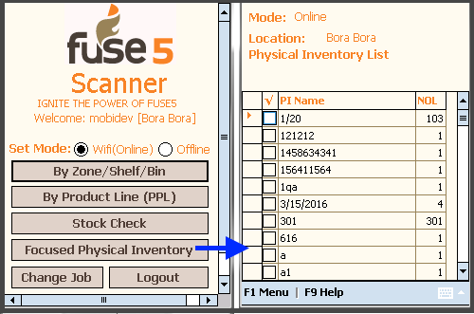
At Physical Inventory List page, select one of PI Name (Physical Inventory Name) and open for scan and reconcile.

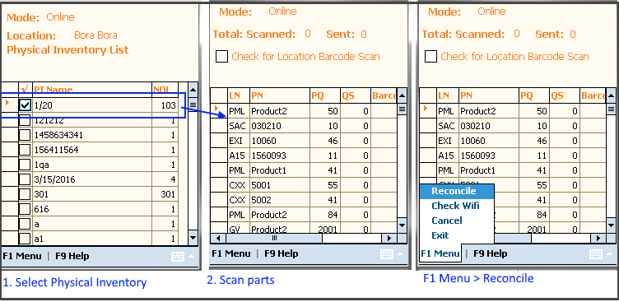
Verify Discrepancy: When user scanned more product qty than physical qty (PQ) and QS = 0, scanner validate it while reconcile and showing discrepancy popup as below:
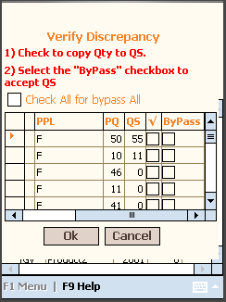
Here, two options for user that bypass with whatever scanned qty or option of copy PQ to QS to make it equal. After checked all this, click 'OK' to reflect changes to main list. Later user can reconcile to Fuse5.

Custom setting for this module in WMS & Scanner Section:
1. Prevent Focused Physical Inventory Over-Scan popup: This setting enable user to by pass verify discrepancy popup by make it 'ON' and if 'Off' – must validate and show popup.

8. DRIVER: This is the delivery person module to deliver each item to its destination. The user will track the truck, delivery of parts, get digital signatures, time stamps and submit them back to Fuse5 delivery log.

User can go to Driver dashboard by selecting Driver Role from user type drop down list.
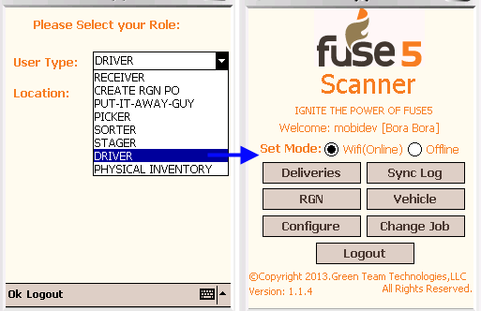

Deliveries: This page lists the pending deliveries assigned to logged user from fuse5.
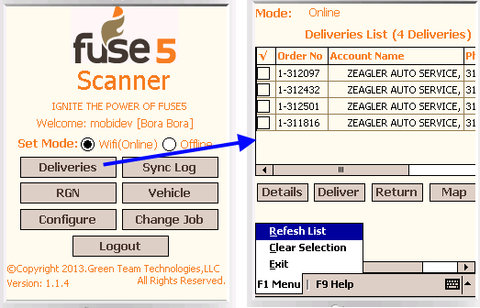

A user can select one or more deliveries and go to next action such as view details, deliver, return order and view location on map.

F1 Menu option:
- Refresh List : To display the latest pending deliveries from fuse5.
- Clear Selection: To clear out the selection of delivery orders.
- Exit: To leave this screen.

Here there are also some navigation buttons also available.

Details: In this screen a user can see the customer and order details of the selected order on the right.
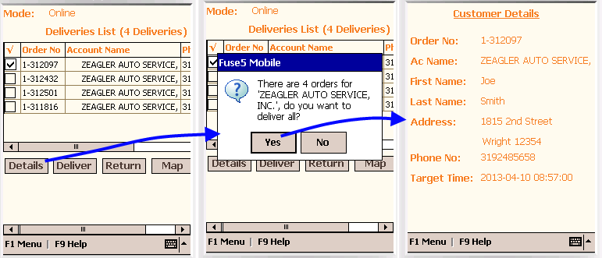
Here the User has selected one order 1-312097 and click Details. A popup appears asking if 'you want to deliver all' accounts deliveries. (ie here there are 4 orders for account 'ZEAGLER AUTO SERVICE INC.').
If the user selects Yes, a Details screen displays a single customer details and multiple order lists with parts.
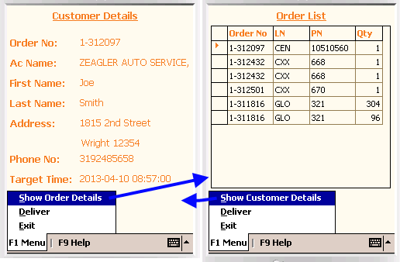
If user click on "NO" from the pop up then, the list parts only for the one selected order will display.
Users can also go to deliver page using hit F1 Menu >> Deliver option to deliver this order.

Deliver: This is the form the driver will use when they arrive at their destination. The driver will deliver packages to customer and take signatures on their palm device.

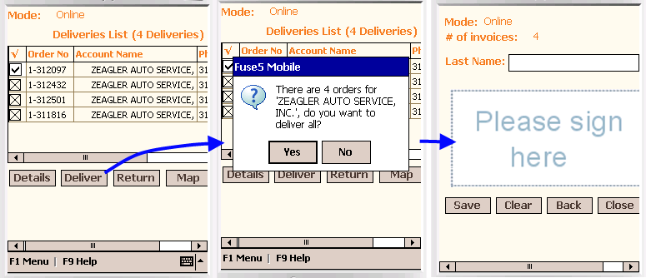
Here a User can fill the details and capture the signature from the customer while delivering the items and save the data into local phone storage for later on sync data into fuse5.
3. Return : When on delivery if the customer wants to make a return then it can be processed by making an entry why it has been returned.
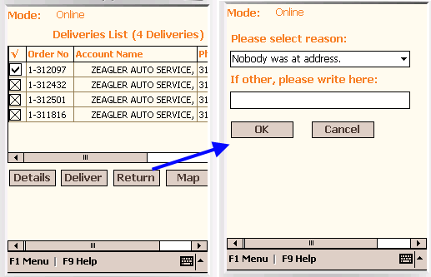
Here the user can select the reason and save the entry. If the user is in online mode then the return will sync to fuse5 or into local storage for later on sync.

- Map: Is used to view a map of the location for the delivery.

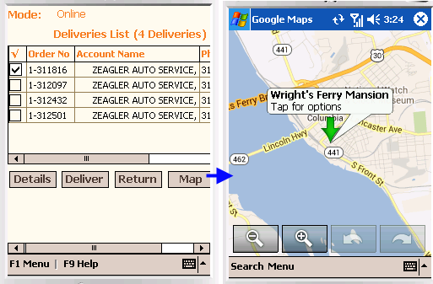
NOTE :
1. The User can not see the map in offline Mode.
2. When offline the user will be storing data for store deliveries and delivery log data into the local database in the phone memory. When they are able to connect, the user will go online and update delivery log into fuse5 by selecting the Sync button on the main screen. In the case where the user forgets to sync, there is a sync all delivery log data option in fuse5 on Page 1 (Delivery list) before listing out deliveries.

Sync Log : To sync the local storage data into Fuse5 when the user comes into online mode. Go to the Sync Log. Select the Sync Log button on dashboard.

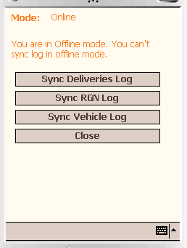

RGN (Return Goods Number): This function allows users to track which products are returned for each Sales Order. Go to the main deliveries screen, Select the RGN button on dashboard.

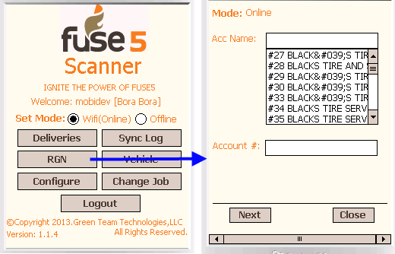
At the above screen, select the account name or account number to search for the account that you would like to list by type name in the textbox and select account# in the below account# textbox. Select the Next button.

Here, the user can fill the form and select add. To view the added list hit “List” button at the right top corner.

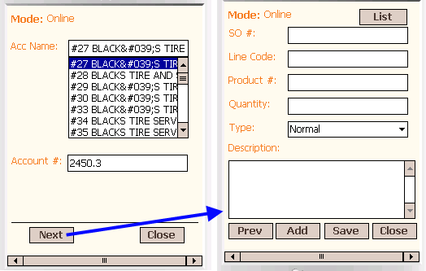

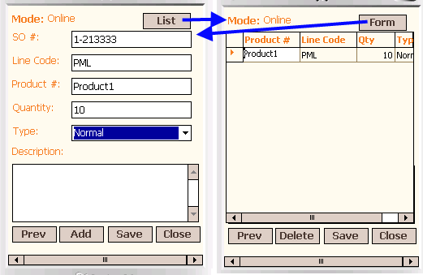
Here the user has added item Product1 for SO# 1-213333 for the type normal return and we can see it on List page. When finished inserting, user can Save data, if online mode then the user will save to fuse5 otherwise the information will be saved into local storage to be synced later to fuse5.
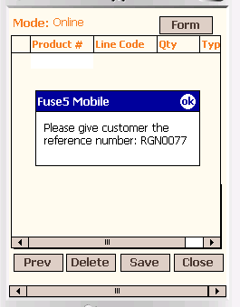

This reference# is designed to give to customers so they can reference this returned goods.

Vehicle: This module will keep track of vehicle (truck) information such as type of truck, which vendor, cost, mileage etc.

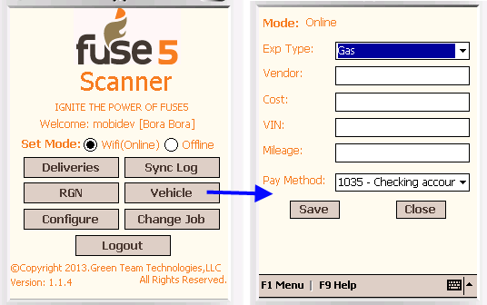
Here the user can type the information and track the entry for each delivery vehicle.

